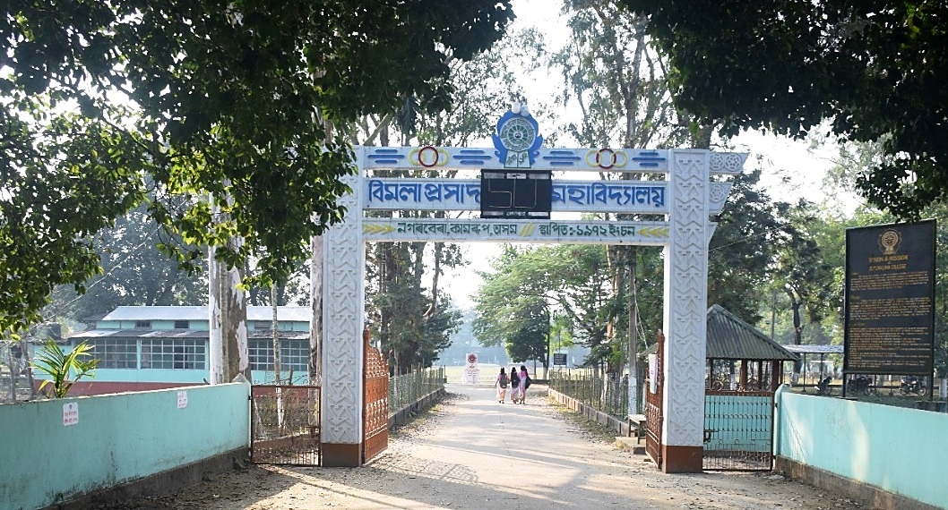


b.p. chaliha college




Result Analysis
Department of Economics,
B. P. Chaliha College, Nagarbera,
Kamrup, Assam
Session:2018-19 to 2022-23

Result Analysis
Department of Economics
B. P. Chaliha College, Nagarbera

Table 1: Year-Wise Pass Percentage
Year | Pass Percentage (Honours)
2018-19 | 100%
2019-20 | 100%
2020-21 | 100%
2021-22 | 100%
2022-23 | 100%

Table 2: Percent-Wise Distribution of Students
Year | No of Students Obtained Marks (Percentage)
Year | 40-50% | 50-60% | 60-70% | 70-80% | 80-90% | $≥$90%
2018-19 | 04 | 04 | 05 | 01 | - | -
2019-20 | - | 01 | 03 | 02 | 01 | -
2020-21 | - | - | 04 | 04 | 01 | -
2021-22 | - | - | 02 | 01 | 02 | -
2022-23 | - | - | 02 | - | -

