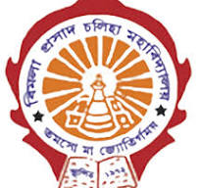
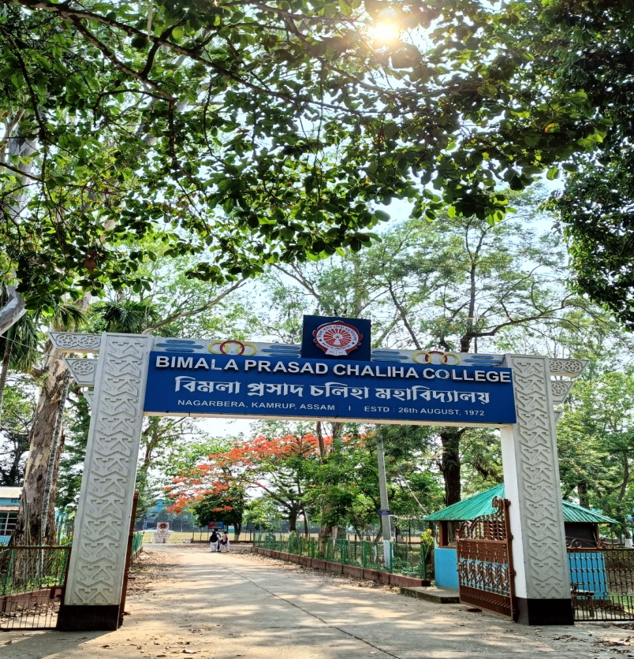

Department of Political Science

B. P. Chaliha College, Nagarbera

Annexure 1
Departmental Activities 2018-19

- Name of the Activity: Inter departmental Quiz Competition
Date: 14/08/2018
Venue: Hall no 4, B. P. Chaliha College

The Department of Political Science organised an inter-departmental Quiz Competition on 14th August on the occasion of Independence Day, 2018. 7 teams joined in the competition. The prizes were distributed by the Principal, B. P. Chaliha College on 15th August at the flag hosting ceremony. The winners were:
- Winner - Abu Sayat and Mukter Hussain, Dept. of Political Science
- Runners up- Mustaque Ameen and Kader Ali, Dept of History

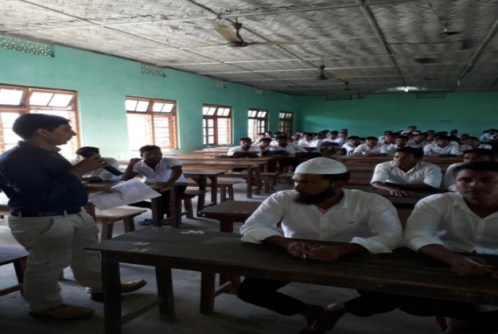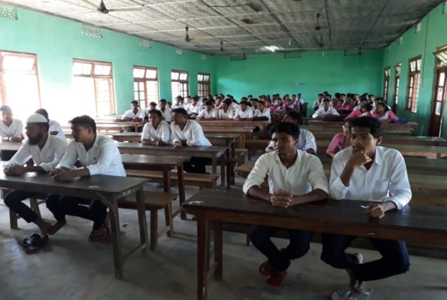
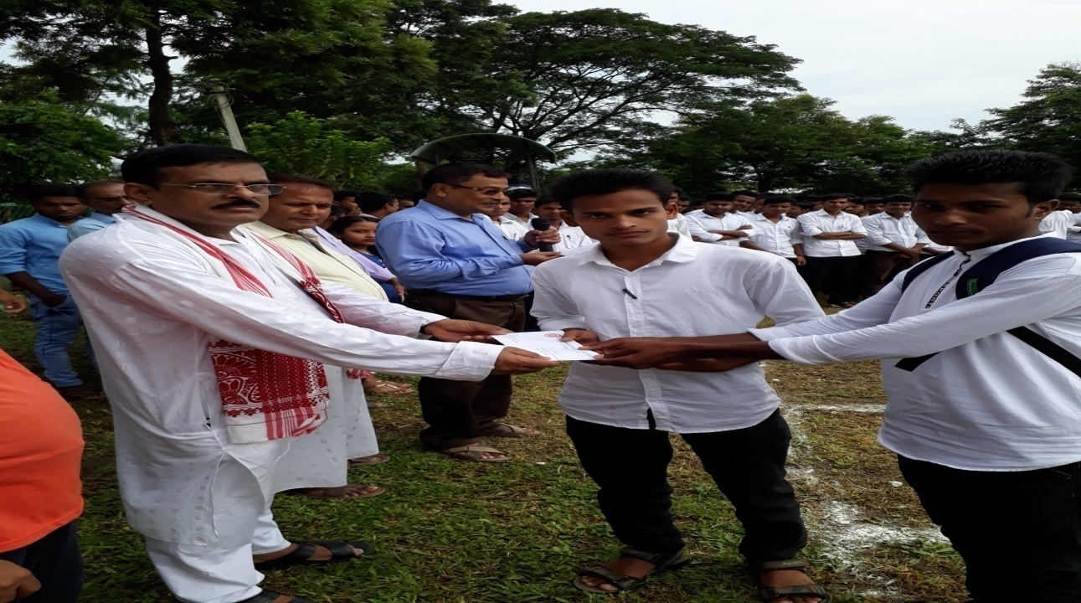

- Name of the Activity: Freshman Social cum Induction Programme
Date: 28/08/2018
Venue: Hall no 1, B. P. Chaliha College

Report: On 28/08/ 2018, Department of Political Science held its Annual Fresher’s Social to welcome the first Semester students. Faculty and participants attended the programme. The first session of the day’s programme, the Fresher’s Social, started at 11:00 am with plantation programme planted by Abdul Hakim, Retired HoD Department of Political Science B. P. Chaliha College. The programme was hosted by Dr. Anjanjyoti Borah, Assistant prof. Department of Political Science. After a brief Welcome Speech by the Mr Noor Alam, HoD, Department of Political Science the Principal, Dr. B. B. Panda delivered a speech welcoming the fresher’s and exhorting the students to be diligent in their studies and to aim for success. After that Dr Diganta Kalita discussed the course objectives of BA in Political Science Courses. Diganta Kalita’s speech was followed by a performance by Manjusri Kalita, 3rd semester, Department of Political Science. Sukur Ali was then called to deliver a speech on behalf of the seniors in which he advised the fresher’s to go the extra mile to set them apart from mediocrity.

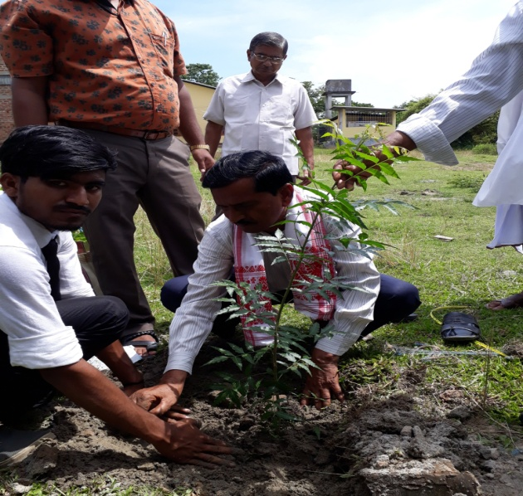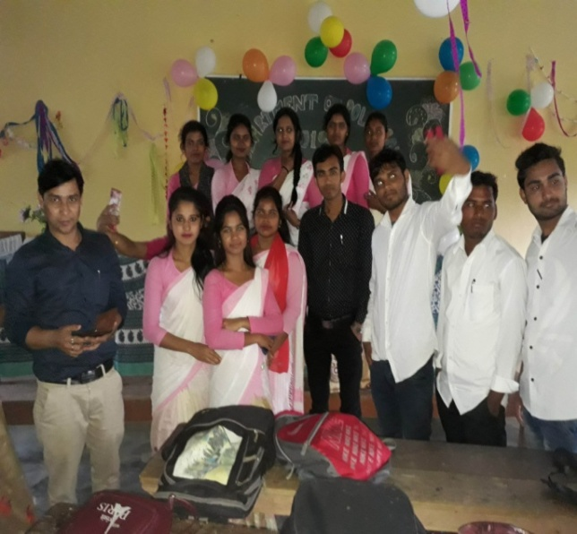

- Name of the Activity: Cleanliness Programme at College Premises
Date: 03/10/2018
Venue: College field
A Cleanliness Programme was conducted by the students of department of Political Science on 3rd October 2018. The students were divided into groups for the cleanliness campaign. All the formed groups who had participated in the campaign were provided with gloves and bio-degradable bags to fill the garbage. The cleanliness campaign also included an awareness program on plastic. Altogether 4 faculty members and 73 students participated in the programme.

- Name of the Activity: Seminar on Women and Rural Development
Date: 12/11/2018
Venue: Hall no 19
In the series of various academic activities departmental seminar was presented by the Department of Political Science, B. P. Chaliha College, on 12th November, 2018. The title of the seminar was ‘Women and Rural Development’. The presentation of topic entitled “Women and Rural Development”, was done by Dr. Anajnjyoti Borah, Assistant Professor of Dept of Political Science. All the faculties and Students were actively present for the seminar. The seminar was conducted in the Depart6mental Classroom.

Altogether 4 faculty members and 26 students were present in the seminar.

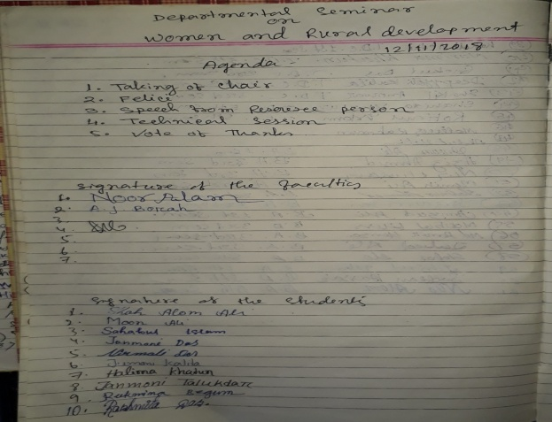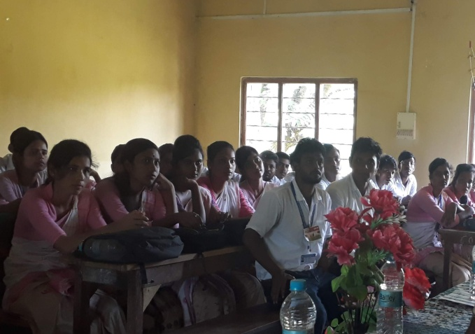

- Name of the Event: Special Talk on Relevance of Indian Constitution
Organised by: Department of Political Science
Date: 26/11/2018
Venue: Hall no 1
A lecture programme on relevance of Indian Constitution' was organised by the department of Political Science on 26th November 2018 on the occasion of Constitution Day, 2018. Prof. Noor Alam, HoD, Department of Political Science delivered the lecture on the making of the constitution. The students of the department participated actively in the lecture programme.

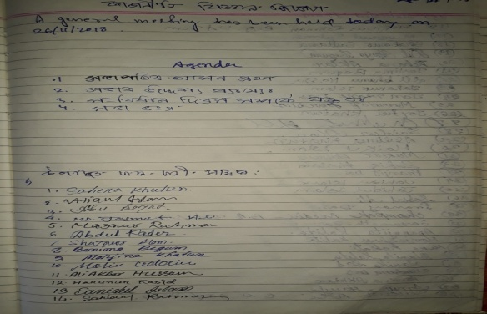
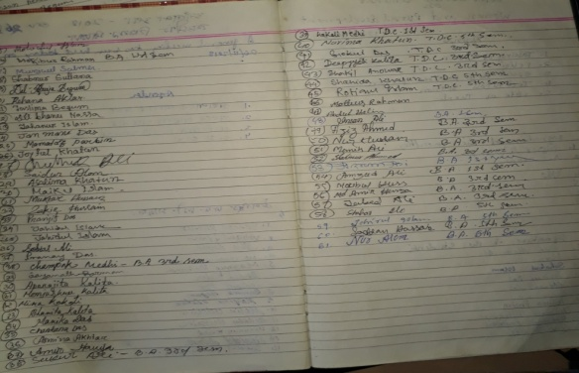

- Name of the Activity: Legal Awareness Programme on Law, Women Empowerment and Free Legal Aid
Organized by: Department of Political Science with support from District Legal Services Authority
Date: 05/04/2019
Venue: Seminar Hall
A Legal awareness program was organised by the department of Political Science for the students of the college. The main objective of this activity was to make the students aware about basic concepts of law. Resource Person was Akhter Fan Ali Borah, Chief Judicial Magistrate, Kamrup. He discussed about the Women Empowerment Acts and free legal aids. 98 students from various departments attended the programme. The aim of the programme was to empower the poor and disadvantaged sections of society to seek and demand justice services. It also aims to empower the youth of our country with the knowledge of their legal rights and duties.
Malabika Kalita, the Child Protection Officer of Kamrup District also took part in the programe.
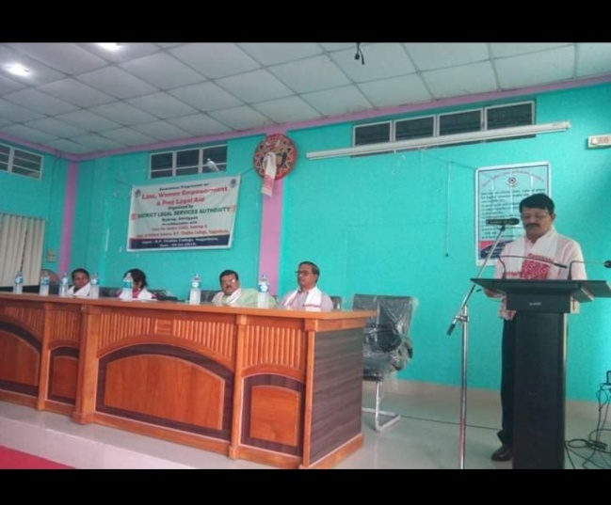
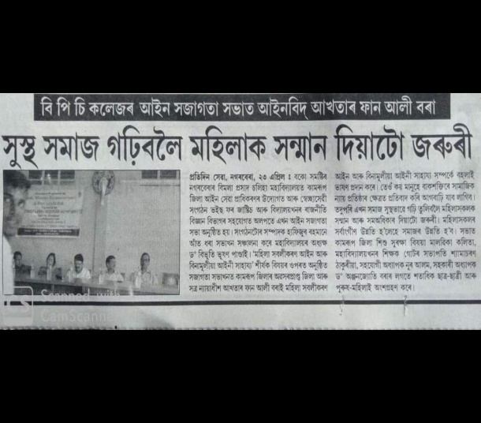

- Name of the Activity: Counseling to BA 6th semester Students
Date: 04/05/2019
Venue: Hall no 1, B. P. Chaliha College

Department of Political Science conducted a Farewell cum Career counseling Program on 4th May, 2019. The effort was made for the courses of BA 4th semester and BA 6th semester students to make them aware about various opportunities after completion of BA courses. The program was carried out for effective 1hour duration. The Resource person for the session was Mr Noor Alam, HoD, department of Political Science. He gave an elaborative introduction about the various opportunities and scope in the academic field. He suggested varied ways and ideas on how to opt the career in abroad.
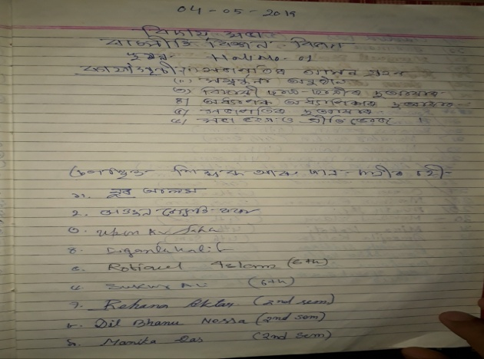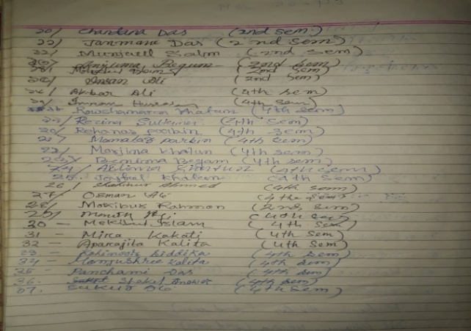
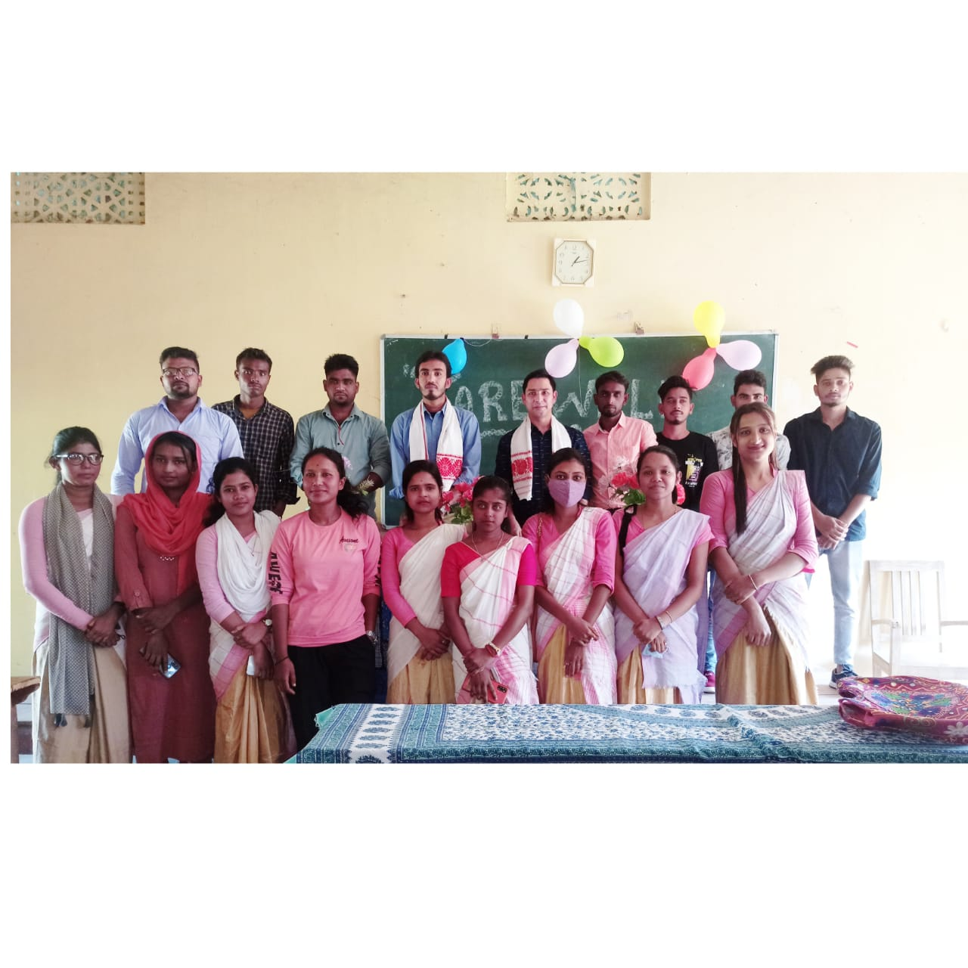
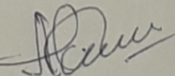
(Noor Alam)
HoD, Department of Political Science

Annexure 2
Departmental Activity Report, 2019-20

Department of Political Science
B. P. Chaliha College, Nagarbera
Session: 2019-20

1. Name of the Activity: Quiz Competition
Date: 21/06/2019
Venue: Room no 19, B. P. Chaliha College
An interdepartmental Quiz Competition was organised by the department of Political Science Sponsored by B. P. Chaliha College on 21st June 2019 on the occasion of International Yoga Day. Quiz Master was Dr Trailokya Deka, Department of Economics and Diganta Kalita, Department of Political Science. 5 teams were joined in the competition. The teams were:
- Jintu Das & Sahina Akhter
- Daizy Pathak & Chandramita Kalita
- Simi Rabha & Bhanita Kalita
- Insan Ali & Mokibur Rahman
- Nazirul Islam &Mohidul Islam
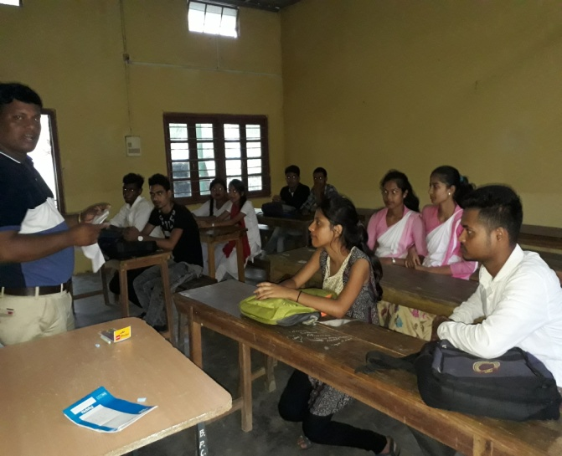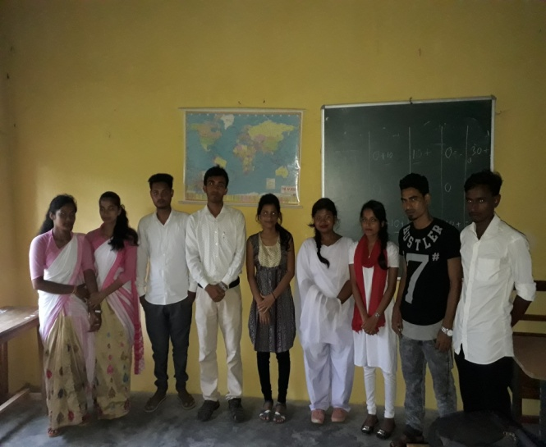

Winner’s teams were- 1ST: Jintu Das & Sahina Akhter, Department of Economics
2nd : Insan ali & Mokibur Rahman, Department of Political Science

2. Name of the Activity: Debate Competition (Topic: Women Empowerment is important for Development)
Date: 14/09/2019
Venue: Hall no 1, B. P. Chaliha College

The department of Political Science organised a debate competition among the students of the department to promote problem solving and innovative thinking of the students on 14th September, 2019. The Topic of the debate was 'Women empowerment is important for development.' Altogether 10 number of student participated in the Debate in which 5 students argued in favour of the parliament and 5students against it.

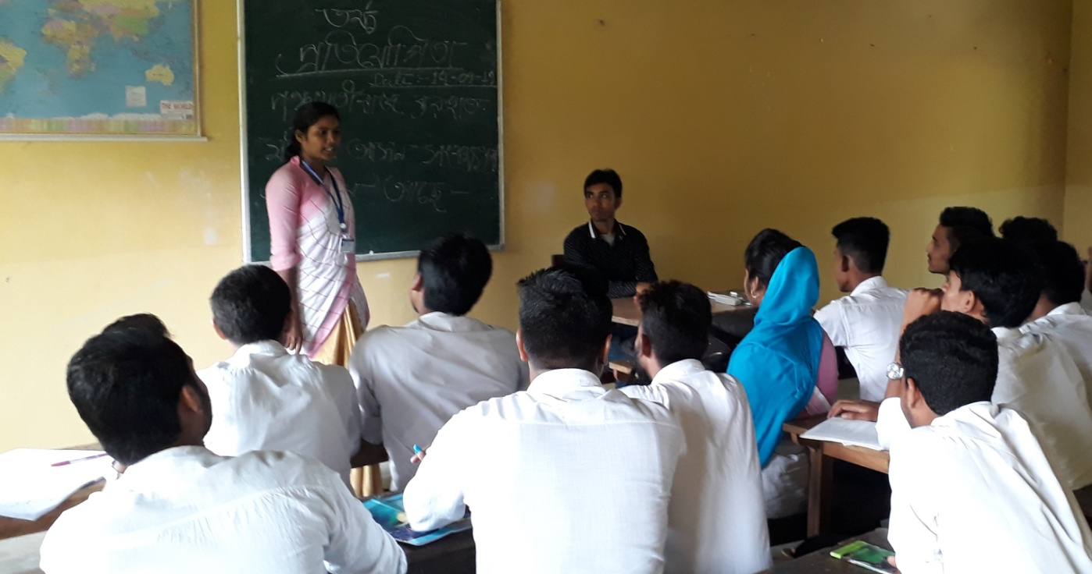

- Name of the Activity: Educational tour to Gangtok, Sikkim
Date: 02nd October to 08th October, 2019
Educational excursions are very important for the overall development of students. During the odd Semester, the department has decided that a study tour was to be held during the Puja Vacation. Then, necessary process was carried out and actions were taken right away. A meeting has been organised and decision was made that Sikkim and Darjeeling as our destination. The undergraduate students (11) and teachers (4) of the department moved for the study tour. The accompanied faculties were Mr. Noor Alam, HoD, Mr Upen Kr Saha, Dr. Anjan Jyoti Borah and Dr Diganta Kalita.
On the first day i.e. 2nd October we started from Dhupdhara in the Evening at 3 p.m. by a bus. Our first destination was Gangtok. We reached Gangtok on 3rd October. After taking a bit of rest we went to the Mahatma Gandhi Market which was very beautiful. We found some good stuff likes sweaters, shawls, and few eatables. After shopping we returned to our hotel rooms.
We have stayed at Gangtok for 3 days and after that we went to Darjeeling and returned home on 08th October.

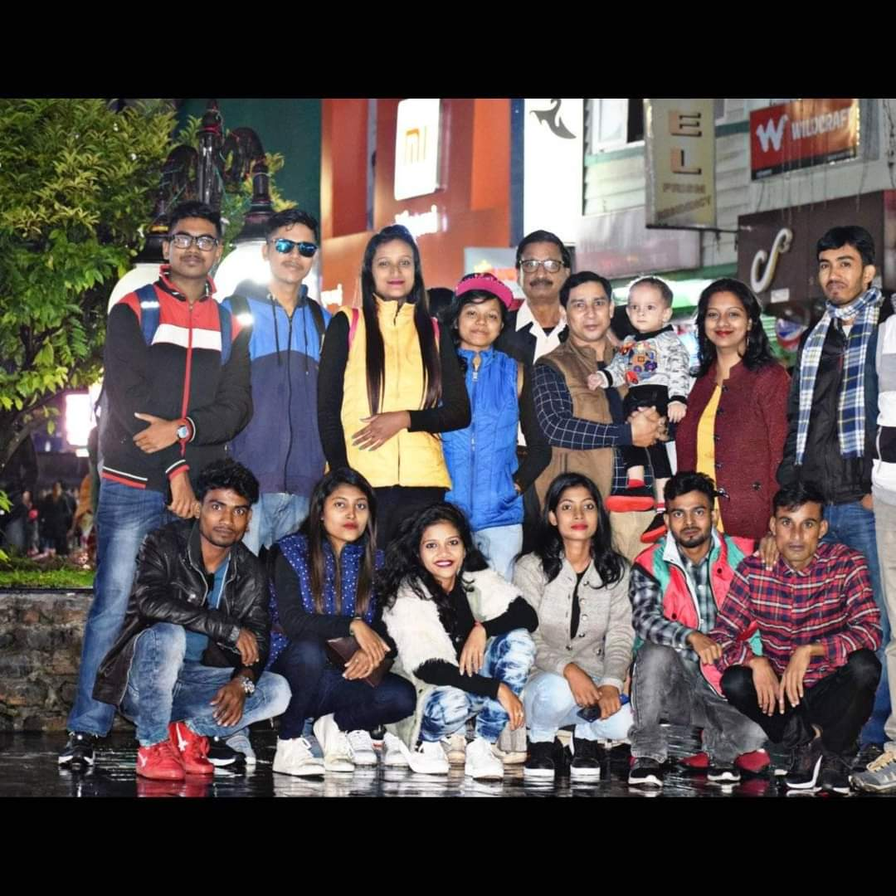

- Name of the Activity: Departmental Seminar on Indian Democracy: Prospects and Challenges
Date: 07/11/2019
Venue: Hall no 1, B. P. Chaliha College

A departmental Seminar was organised by the department of Political Science on Indian Democracy: Prospects and Challenges on 07/11/2019. The seminar was presided over by Mr Noor Alam, HoD, Dept. of Political Science. The keynote address was delivered by Upen Kr Saha, Assistant prof. Department of Political Science, B. P. Chaliha College. Abdul Hakim, The Retired HoD of department of Political Science was the Resource person. Speaking on the topic he presented a historical perspective on the concept. 8 papers have been presented by the presenter and total 46 students were present in the seminar.

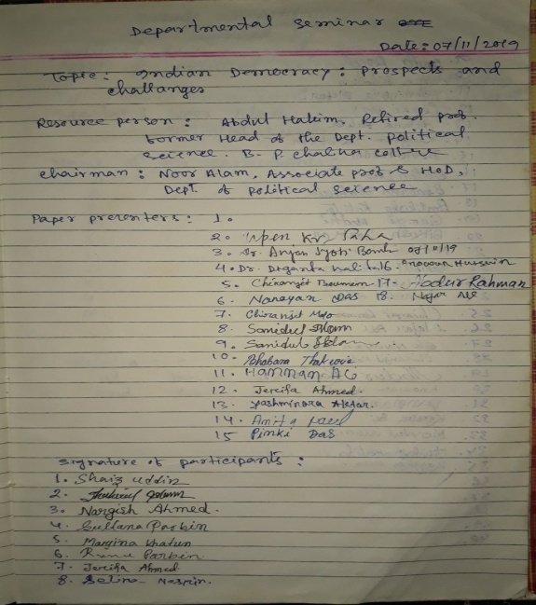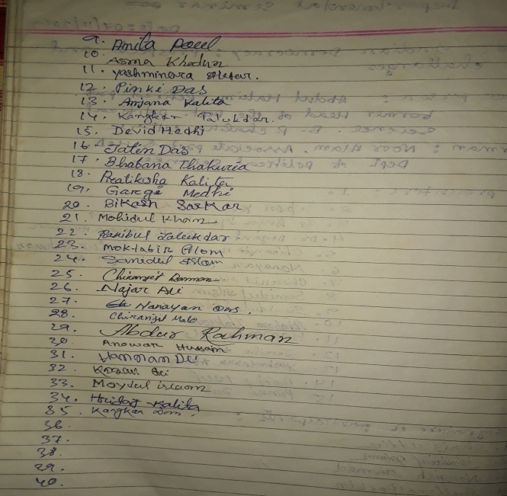

- Name of the Activity: Essay Writing Competition on the occasion of Gandhi Jayanti
Date: 01/10/2019
Venue: Hall no 3, B. P. Chaliha College
The department of Political Science organised an Essay Writing competition among the students of the college to promotes Writing and creative skill of the students on 1st November, 2019. Gargi medhi has secured first position in the event. Further, she has secured first position in the inter college and University essay writing Competition organised by Gauhati University.

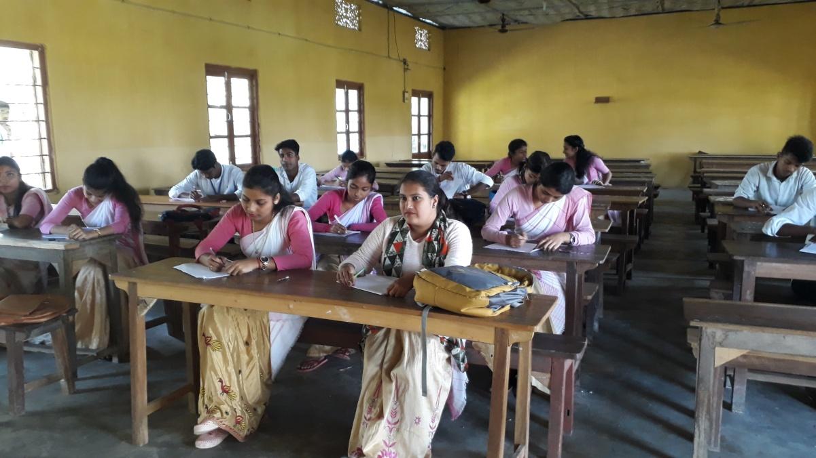

- Name of the Event: Special Talk on Indian Democracy
Date: 26/11/2019
Venue: Seminar Hall, B. P. Chaliha College
A lecture programme on Indian Democracy' was organised by the department on 26th November 2019 on the occasion of Constitution Day. Prof. Noor Alam, HoD, Department of Political Science delivered the lecture and elaborates on the topic Indian Democracy in present context.

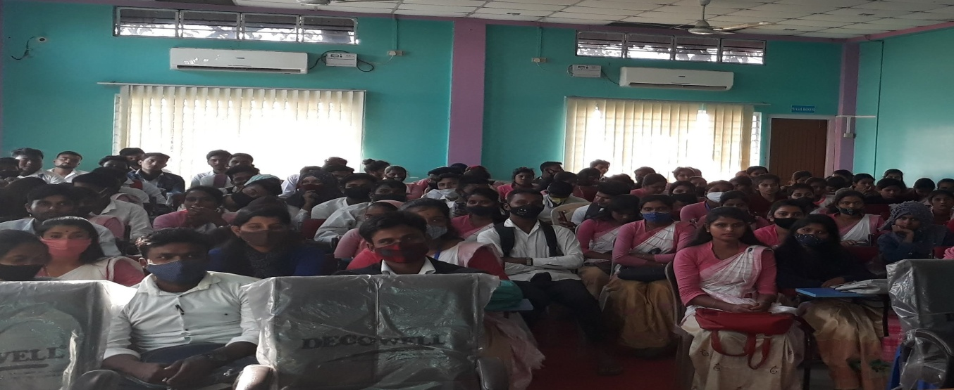

- Name of the Event: Educational Excursion to Pobitora Wildlife sanctuary
Date: 24/02/2020
Educational Excursion is a important part of Education system. The department of Political science has given this opportunity to its students and taken them on an educational trip to Pobitora wildlife sanctuary, where they have witnessed lush greenery and the animals like one horn Rhino. This type of trips gives students an exposure to the practical fields of life. Altogether 42 students and 3 faculty member were the part of this trip.
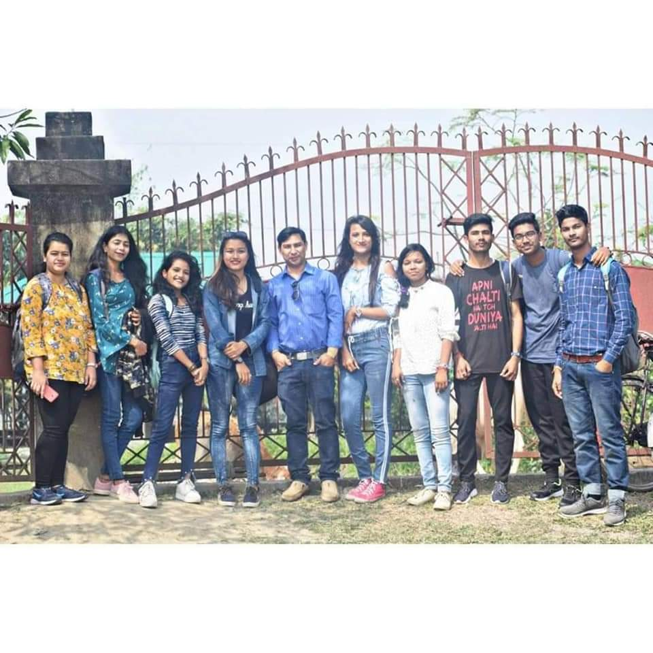
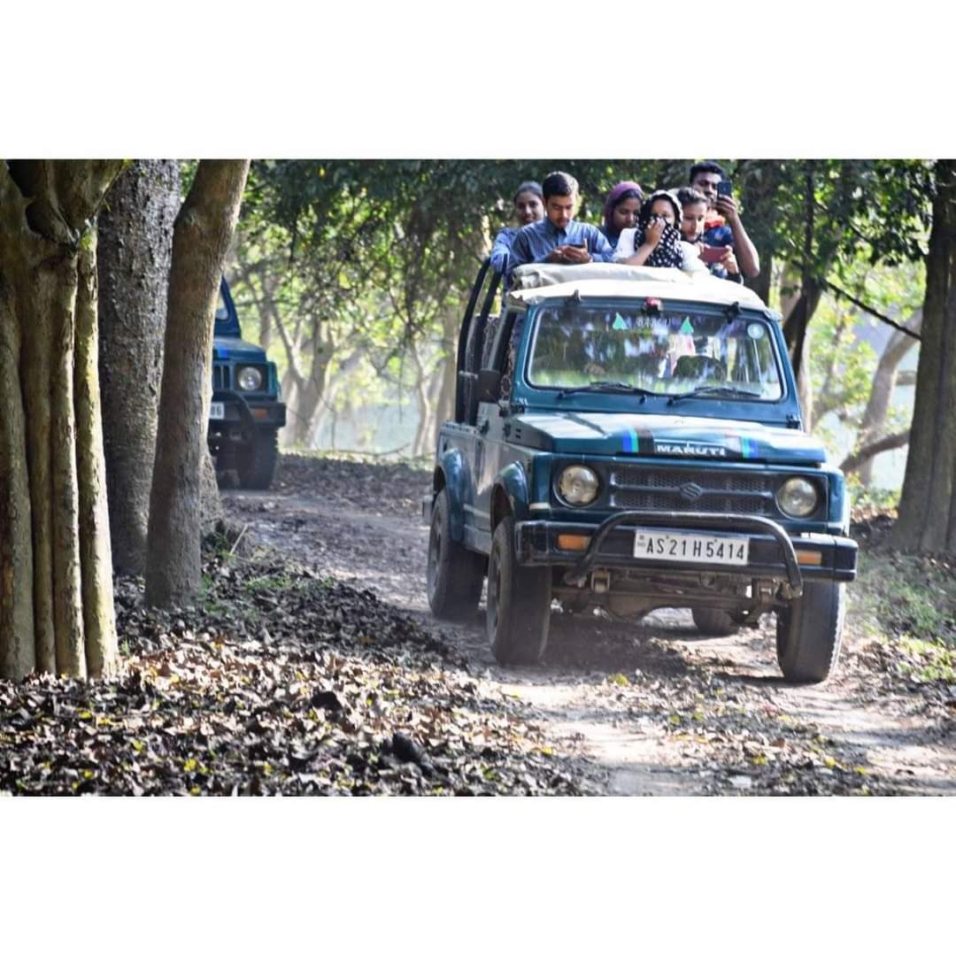

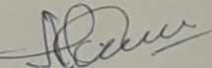
(Noor Alam)
HoD
Dept. of Political Science

Annexure 3
Departmental Activity Report
2020-21

Department of Political Science
B. P. Chaliha College, Nagarbera
2020-21

- Name of the Activity: National Webinar on Covid-19 Pandemic: Changing Contours of Indian Political Economy
Date: 21/08/2020
Platform: Google Meet

The Department of Political Science in Collaboration with IQAC, B. P. Chaliha College organized Online One-Day National Webinar on “Covid-19 Pandemic: Changing Contours of Indian Political Economy” on 21st August, 2020. Apart from a good number of students, the programme was attended by teachers/faculty/research scholars/experts from different colleges of India. The programme formally began with the welcome address delivered by college Principal Dr. B. B. Panda. Followed him Dr. Dhiresh Sakravarty delivered the Inaugural Speech. Prof. Jayanta Krishna Sarmah from Gauhati University delivered the keynote speech. Resource person was Prof. Manash Chakravarty from University of North Bengal.

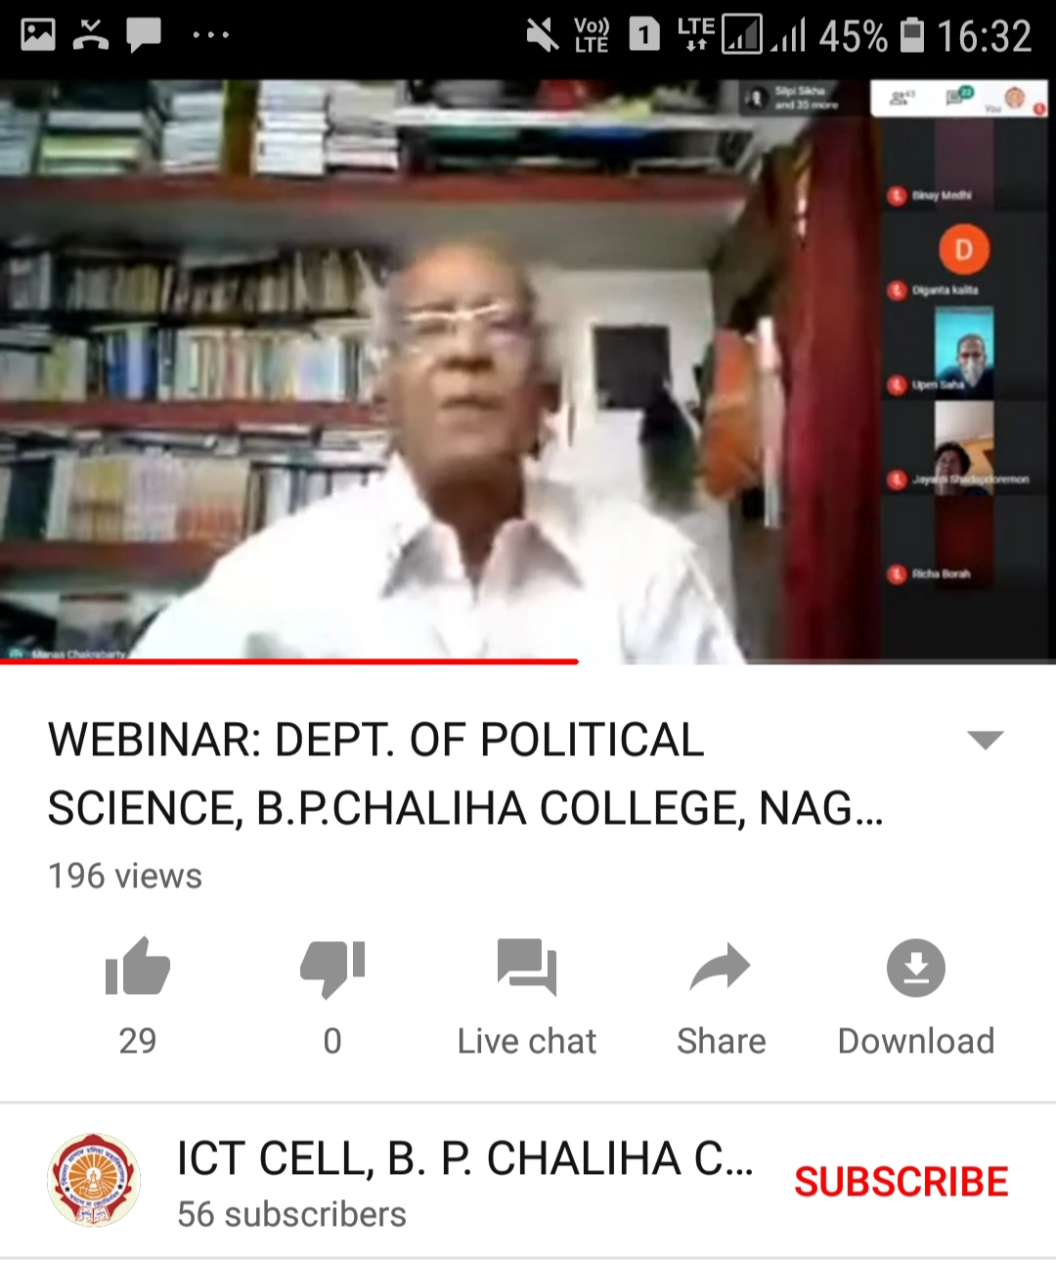

- Name of the Activity: Article writing competition and Lecture on the philosophy of the Indian Constitution
Date: 26/11/2020
Venue: Hall no 1

A lecture programme and article writing competition had been organised by the department of Political Science on the occasion of Constitution Day, 2020. Mr Noor Alam, HoD, Department of Political Science inaugurated the programme and Dr. Anjanjyoti Borah, the speaker of the programme delivered a lecture on the Philosophy of the Indian Constitution. Total 23 no of students virtually attended the programme.
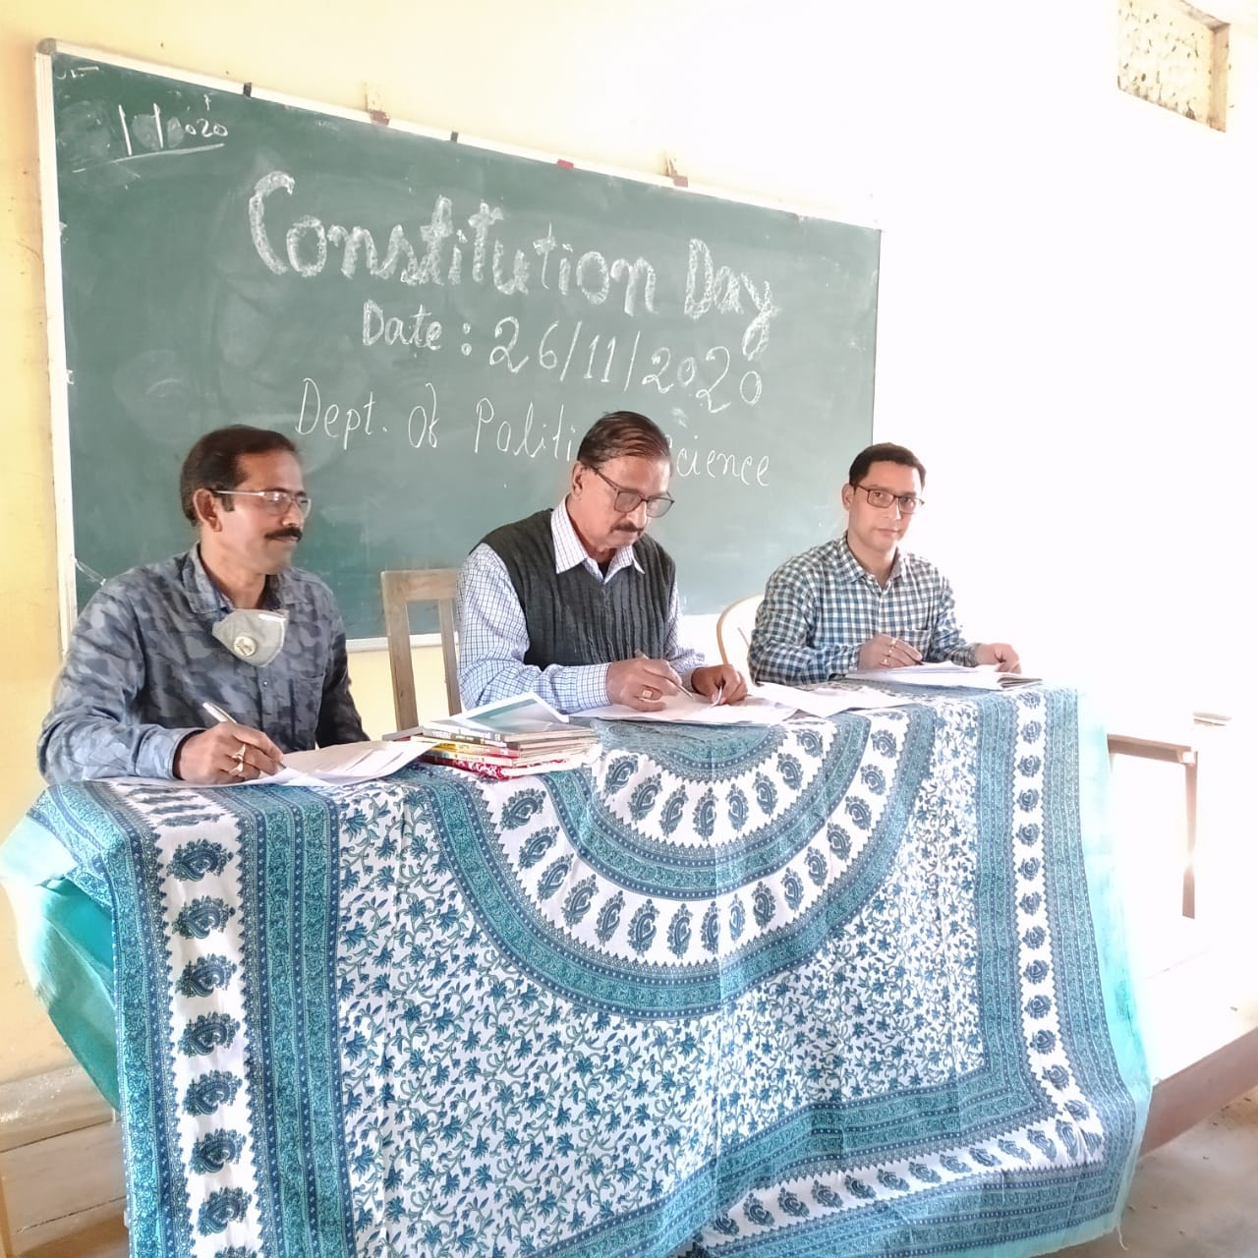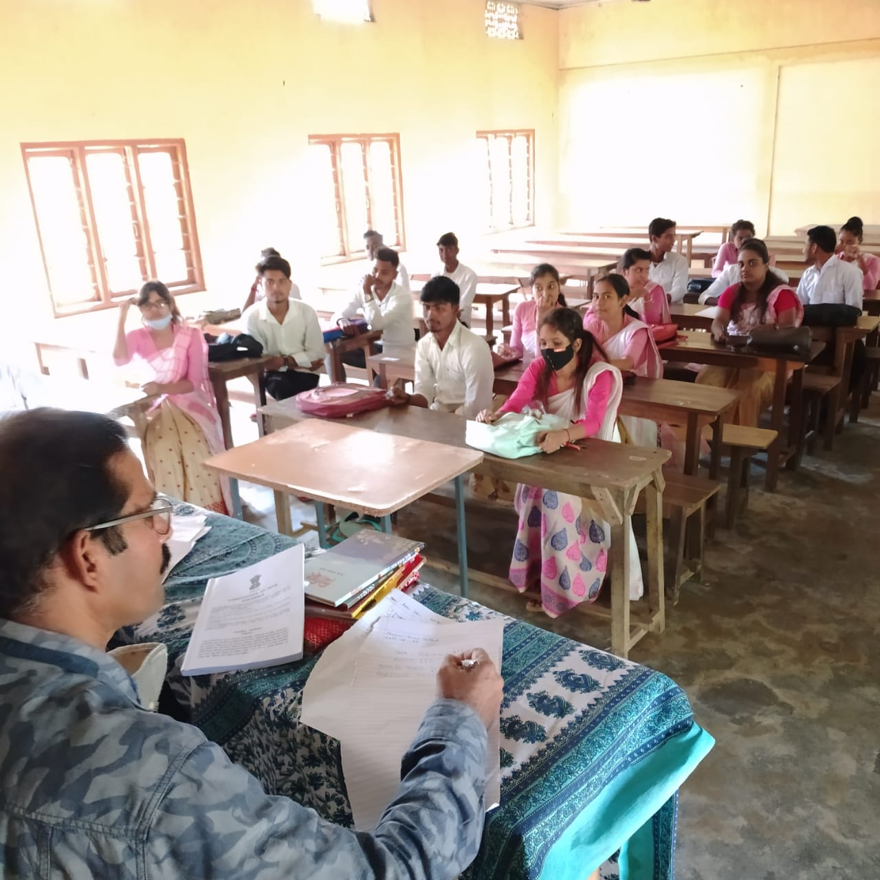

- Name of the Activity: Educational tour to Bogamati, Assam
Date: 10/01/2021
The Department of Political Science decided to go for an educational tour to Bogamati, Goreswar, Assam on 10th January 2021. Accordingly the team has started the journey on 10th January at 4 am. 45 students and 4 faculty members were the part of this tour.

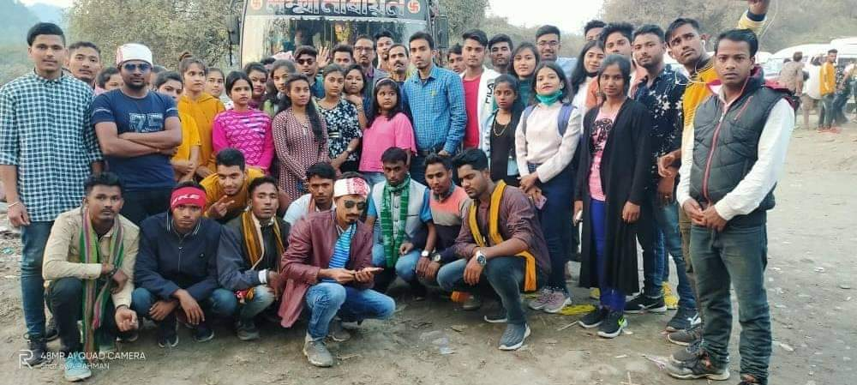

- Name of the Activity: Voters awareness Programme
Date: 02/02/2021
Venue: Hall no 4
The Depart6ment of Political Science organised a Voters Awareness Programme on 02/02/2021 at hall no 4 of the college premises. Resource Person was Miss Trishna Saikia and Dipika Upadhyay, Office the Deputy Commissioner, Amingaon, Kamrup, Assam. Dr B. B. Panda, Principal of B. P. Chaliha College inaugurated the programme.

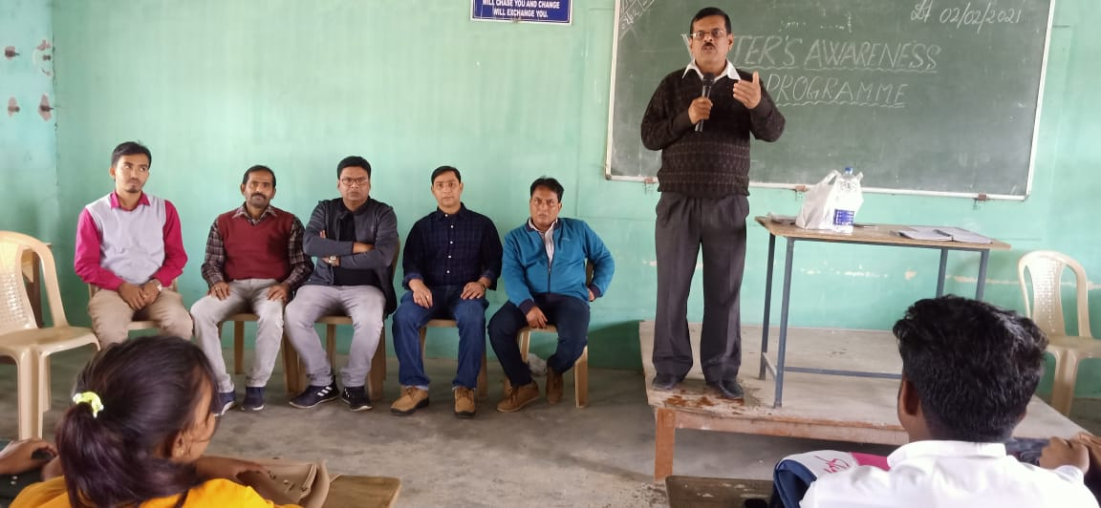

- Name of the Activity: Essay Writing Competition

Date: 19/03/2021
Venue: Hall no 4
An Essay Writing Competition on the occasion of Azadi Ka Amrut Mahotsav was held on 19/03/2021. Department of Political Science organised this competition. The theme of the competition was ' Role of Women in the development of Nation'. Winners were Bikram Barman, BA 1ST Semester, Ankuma Das, BA 5Th semester and Hiyamoni Pathak, BA 1st Semester.

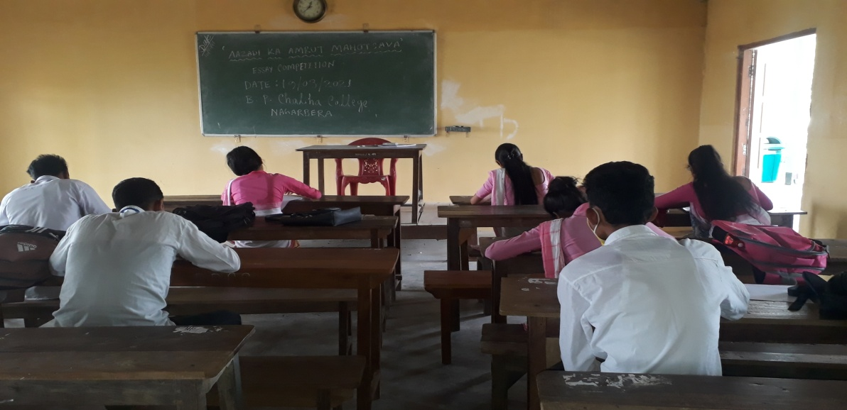

- Name of the Event: Seminar on Indian Freedom Struggle
Date: 12/03/2021
Venue: Hall no 4
The Department of Political Science organised a seminar on Indian Freedom Struggle on 12/03/2021. Dr. B. B. Panda, Principal, B P Chaliha College delivered the inaugural speech. Followed him, resource person Mr. Noor Alam, Associate professor, Department of Political Science and Mr Basanta Kalita, Assistant Professor, Department of History delivered valuable speech on the said Topic.

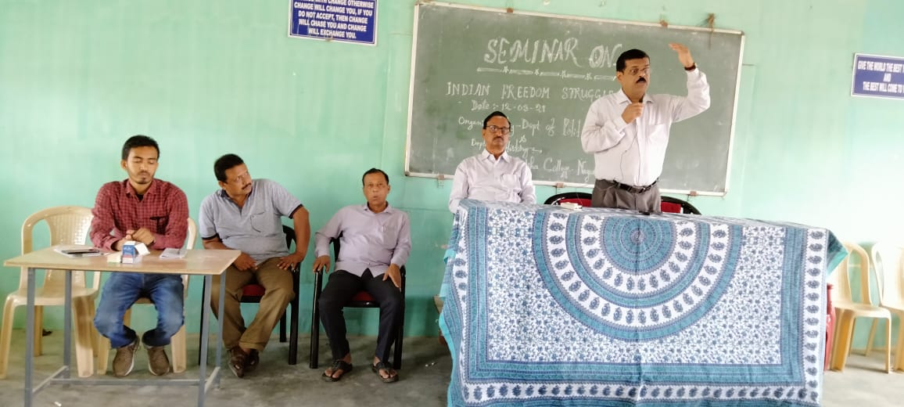

- Name of the Event: Farewell cum Counseling Programme
Date: 20/06/2021
Venue: Hall no 1
A farewell cum counseling programme was conducted by the department of Political Science for the 6th semester students of Political Science on 26/06/2021. All the final semester students of the department took part in the programme. Dr. Anjanjyoti Borah highlights the point that our character deserves our destiny in our future life and should behave on the basis of reason.
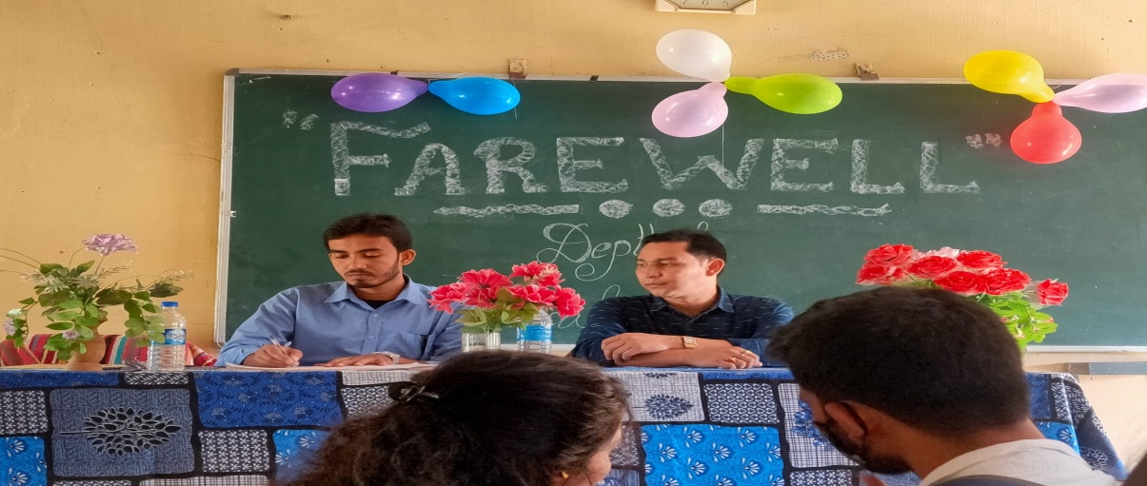

(Noor Alam)
HoD
Dept. of Political Science

Annexure 4
Departmental Activity Report
2021-22

Department of Political Science
B. P. Chaliha College, Nagarbera
2021-22

- Name of the Activity: Freshman Social cum Induction Programme
Date: 26/11/2021
Venue: Hall no 1
The freshmen social cum Induction programme was held on 26/11/2021 in the department of political science. The main objectives of this programme are to welcome the fresher’s into the college and motivate them in learning. In this programme the Course Objectives also bring into focus before the students.

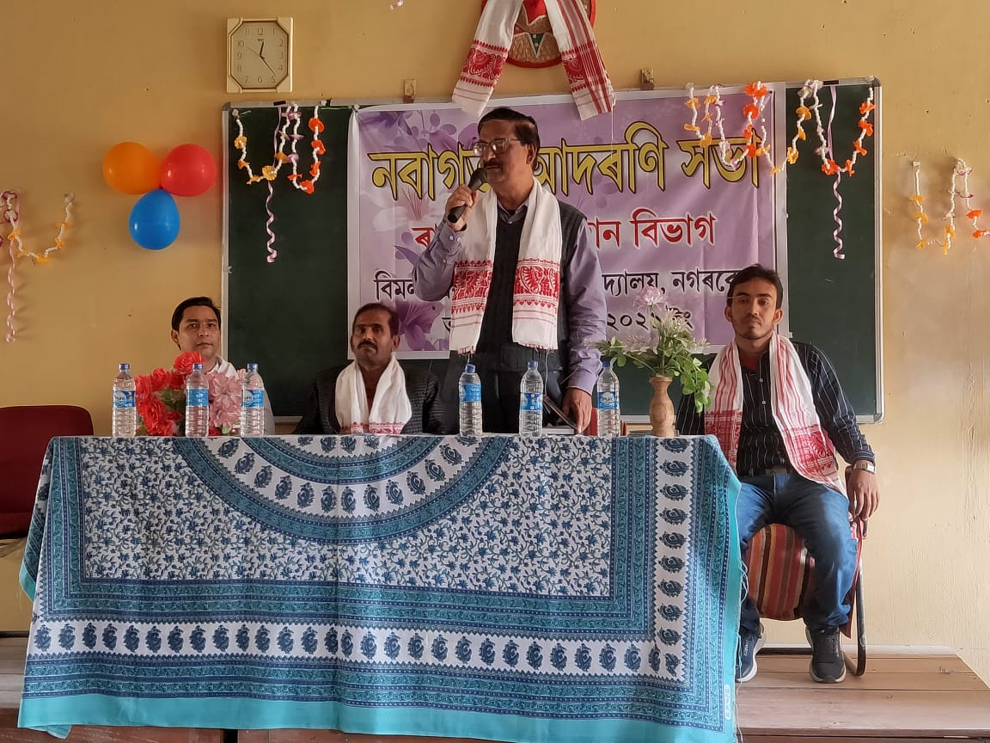
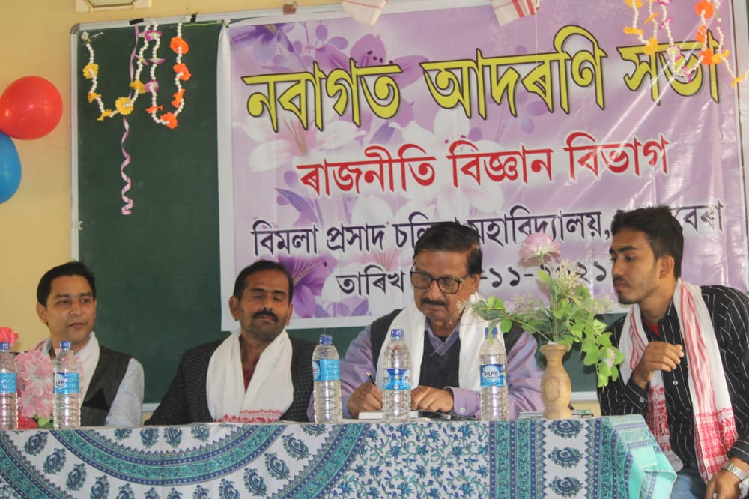

- Name of the Activity: Talk on Relevance of the Constitution in present day context
Date: 26/11/2021
Venue: Hall no 1
A lecture programme on the occasion of Constitution Day, 2021 was organised by the department of Political Science on 26/11/2021 to cherish the glory and reaffirm our commitment to uphold the ideology of great Indian constitution. Mr Upen Kumar Saha, Assistant Professor of Department of Political; Science talked on the relevance of the Constitution in present day context. After that an interactive session was held with the students. The Programme was held just after the conclusion of freshman social Programme.

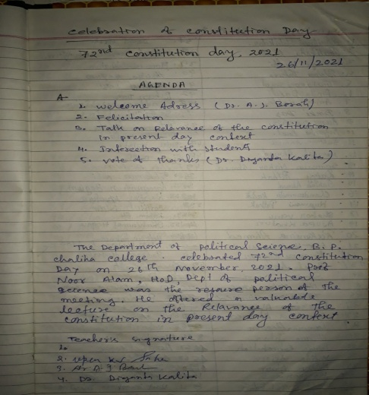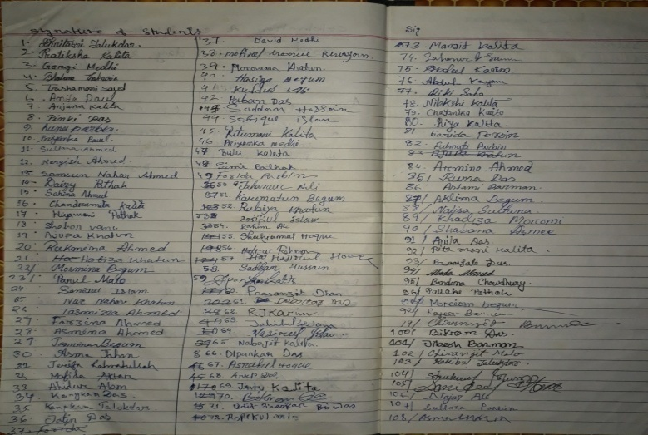
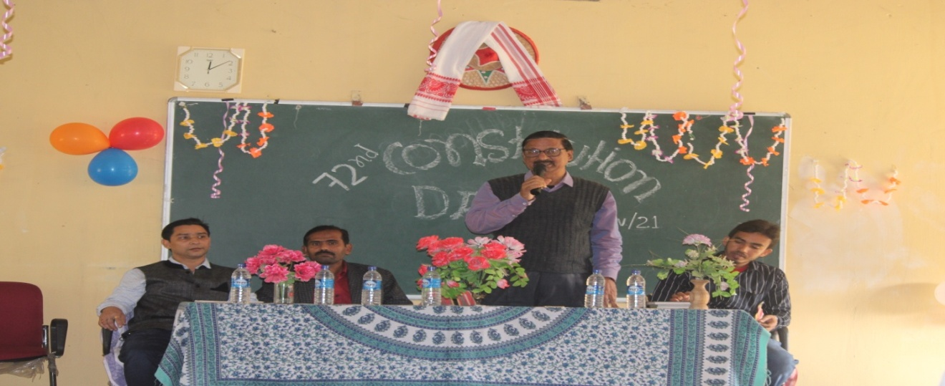

- Name of the Activity: Lecture Programme on ‘New Education Policy: Its Challenges and Prospects’

Date: 24/12/2021
Venue: Seminar Hall
A special talk on 'New Education Policy: Its challenges and Prospects' was organised by the department of Political Science on 24/12/ 2021. Resource person was Prof. Jayanta Krishna Sarmah, Department of Political Science, Gauhati University. The Lecture Programme was inaugurated by Dr. B. B. Panda, Principal of B. P. Chaliha College and welcome address has been given by Mr Noor Alam, Head of the Department of Political Science. Altogether 98 students and 23 faculties attended the lecture.
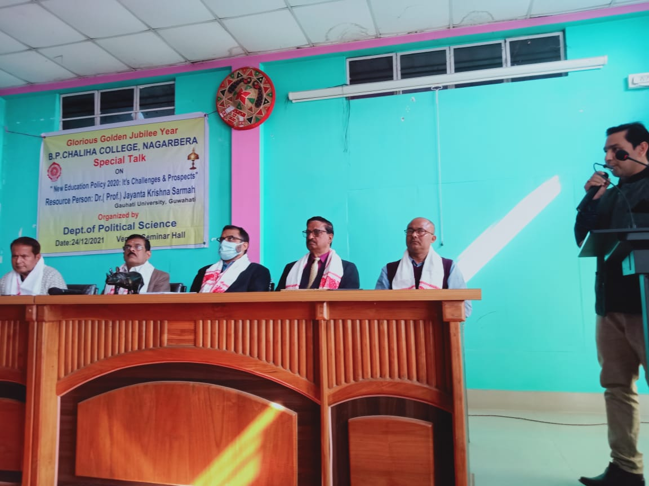
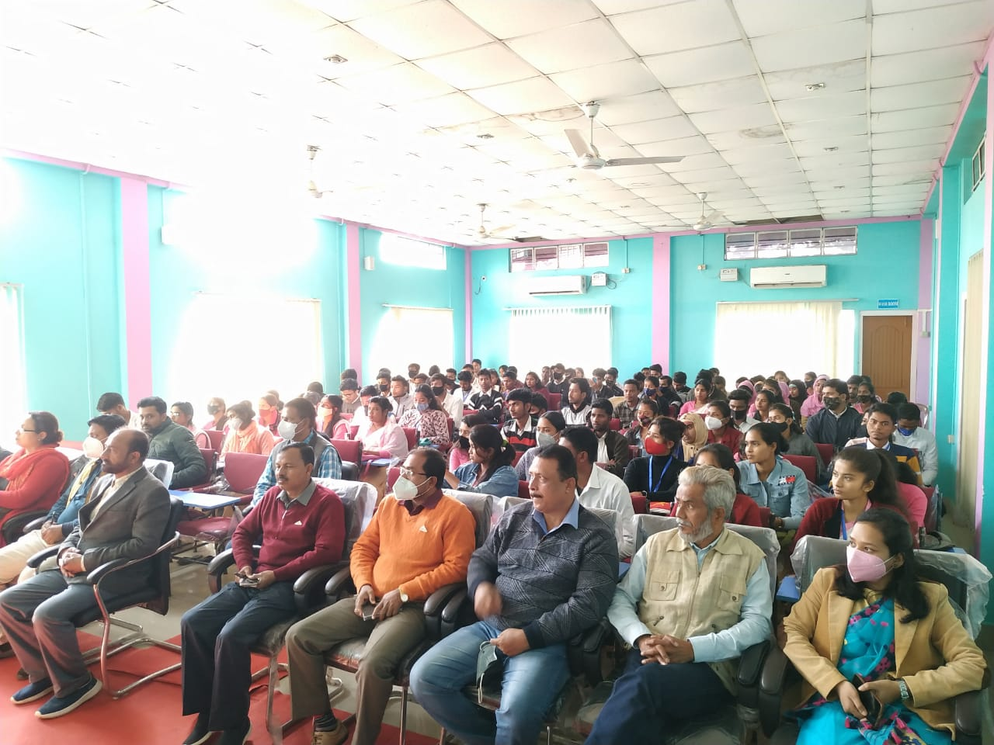

- Name of the Activity: Educational tour to Mwnabili, Kokrajhar
Date: 05/01/2022
The most awaited day of the year was the departmental field trip to MWANABILI, Kokrajhar, Assam . Mwnabili picnic spot gave greenery and the beauty of nature. We started at 5AM in the morning with prayer and a feeling of a great day ahead. The student were extremely excited and kept singing songs in the bus till they reached the venue.
Mwnabili Picnic spot & Eco Tourism situated at Sadu Mara of Malivita touching the Bhutan Border under Chirang District, BTR, Assam. It is a beautiful place to visit and people throng here for picnic and enjoy at natural beautiful river with cold and clean water.
45 students along with 4 teachers were the part of this wonderful picnic cum field visit. It exudes bursts of magic throughout the day. The students were amazed to see the beauty of nature of the venue.
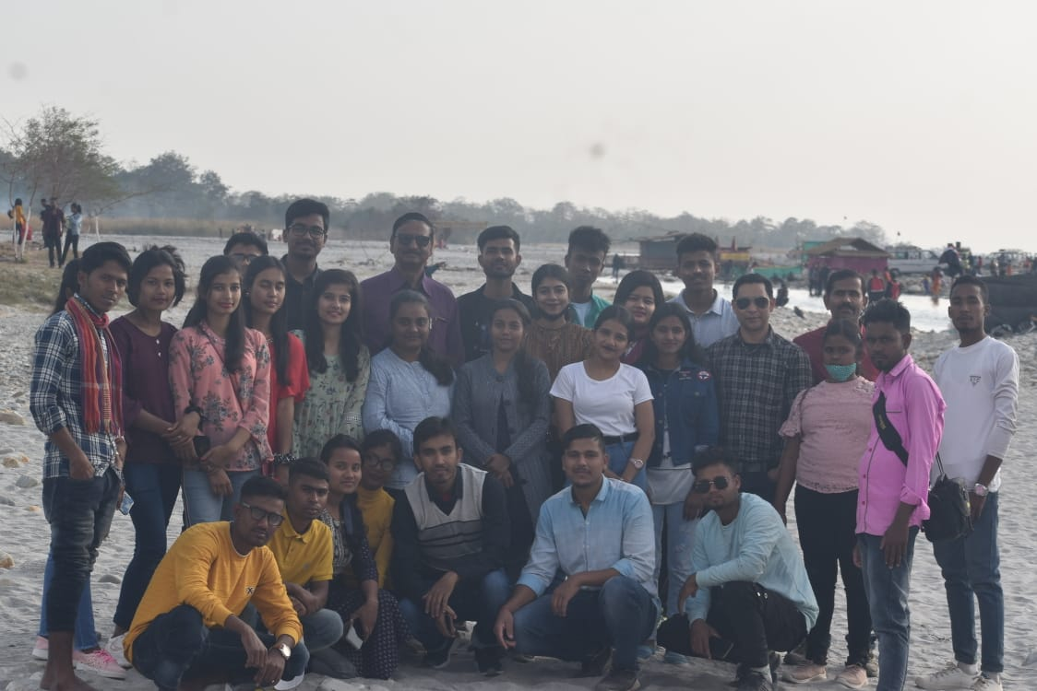
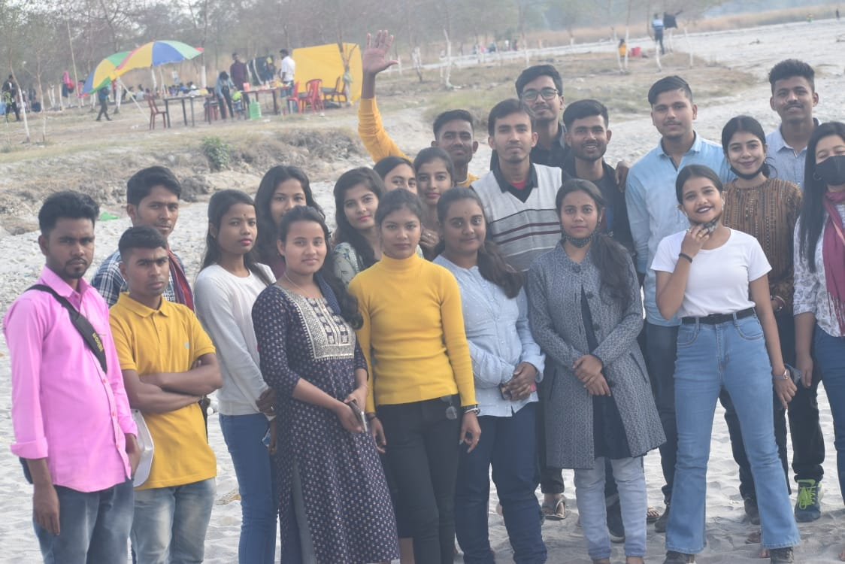

- Name of the Activity: Departmental seminar on ‘Developing a research agenda’ (Research Methodology) in association with department of Assamese
Date: 07/05/2022
A training Programme on Developing a research agenda through' was organised by the department of political Science on 7th May, 2022. Dr Diganta Kalita, Assistant Professor was the resource person. The target students are BA Honours students.

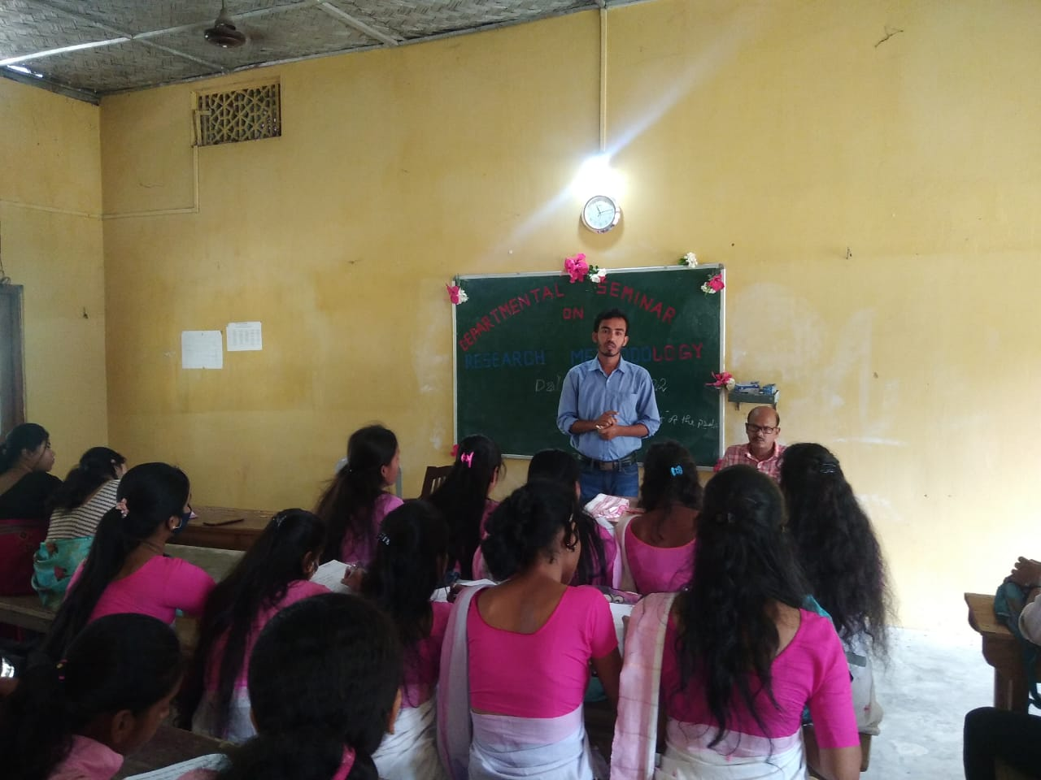

- Name of the Activity: Cleanliness activities in the college campus
Date: 02/05//2022
A cleanliness drive has been arranged by the students of the department of Political Science on 02/05/2022 in the college campus. Students from our department actively participated in the activity.
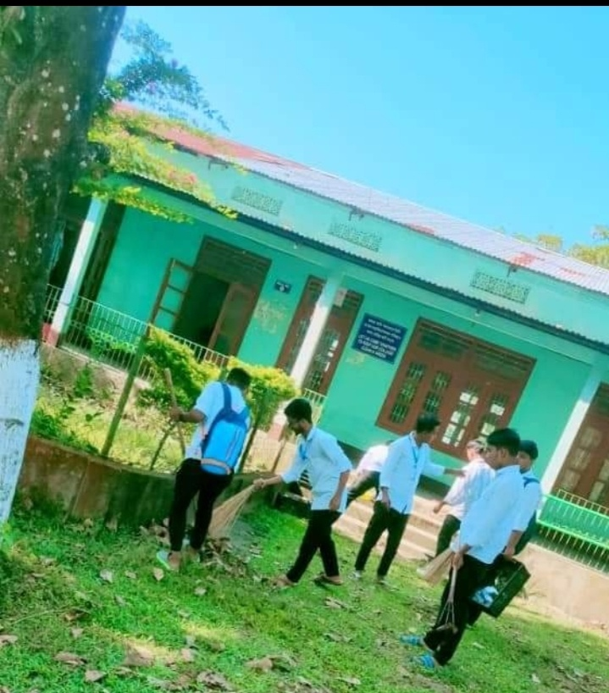

- Name of the Activity: Counseling on Filling up nomination paper for election of Gaon Panchayat member
Date: 21/05/2022
Venue: Room no 19

There is a skill paper titled 'Panchayati Raj in Practice' in the BA fourth semester course. This course acquaints students with the Panchayati Raj Institutions and their actual working. A counseling programme on 'how to fill up nomination papers in the election of Panchayati Raj Institutions' was organized by the department of Political Science on 21/05/2022 to literate the students about the election system.

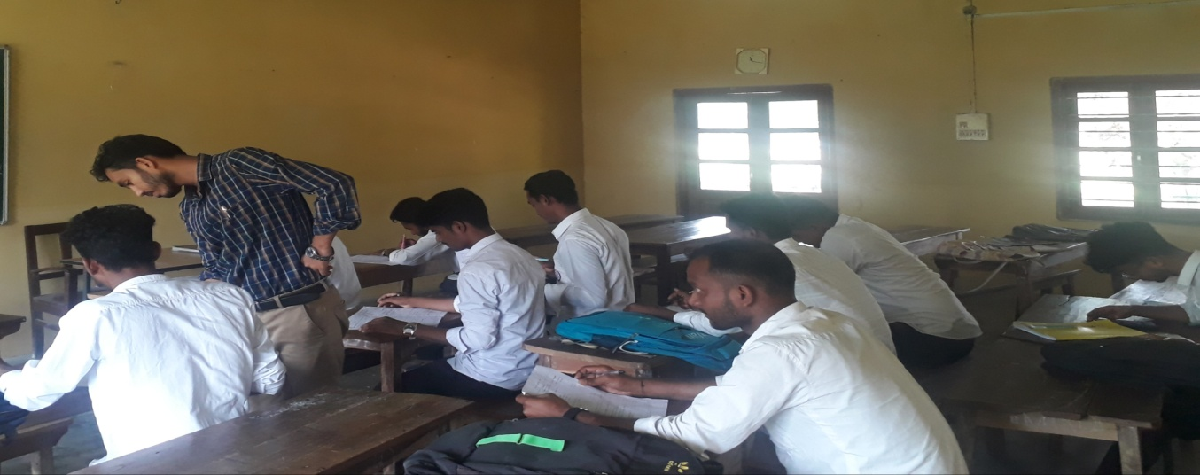

- Name of the Activity: Farewell cum Counseling Programme
Date: 18/06/2022
Venue: Hall no 1
The Counseling cum farewell programme was conducted by the department of Political Science for the 6th semester students of Political Science on 18/06/2022. All the final semester students of the department took part in the programme. Dr. Diganta Kalita highlights the point that our character deserves our destiny in our future life and should behave on the basis of reason.
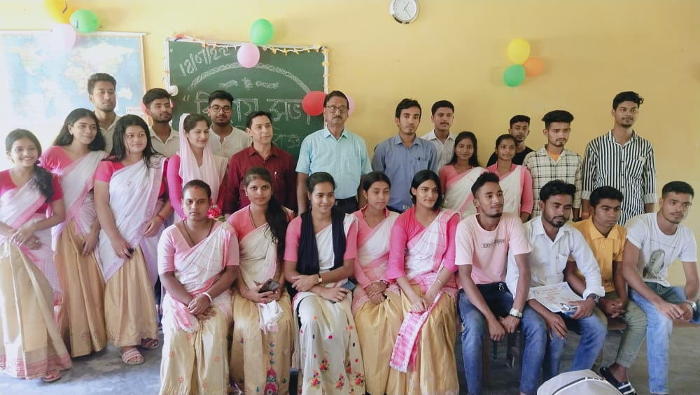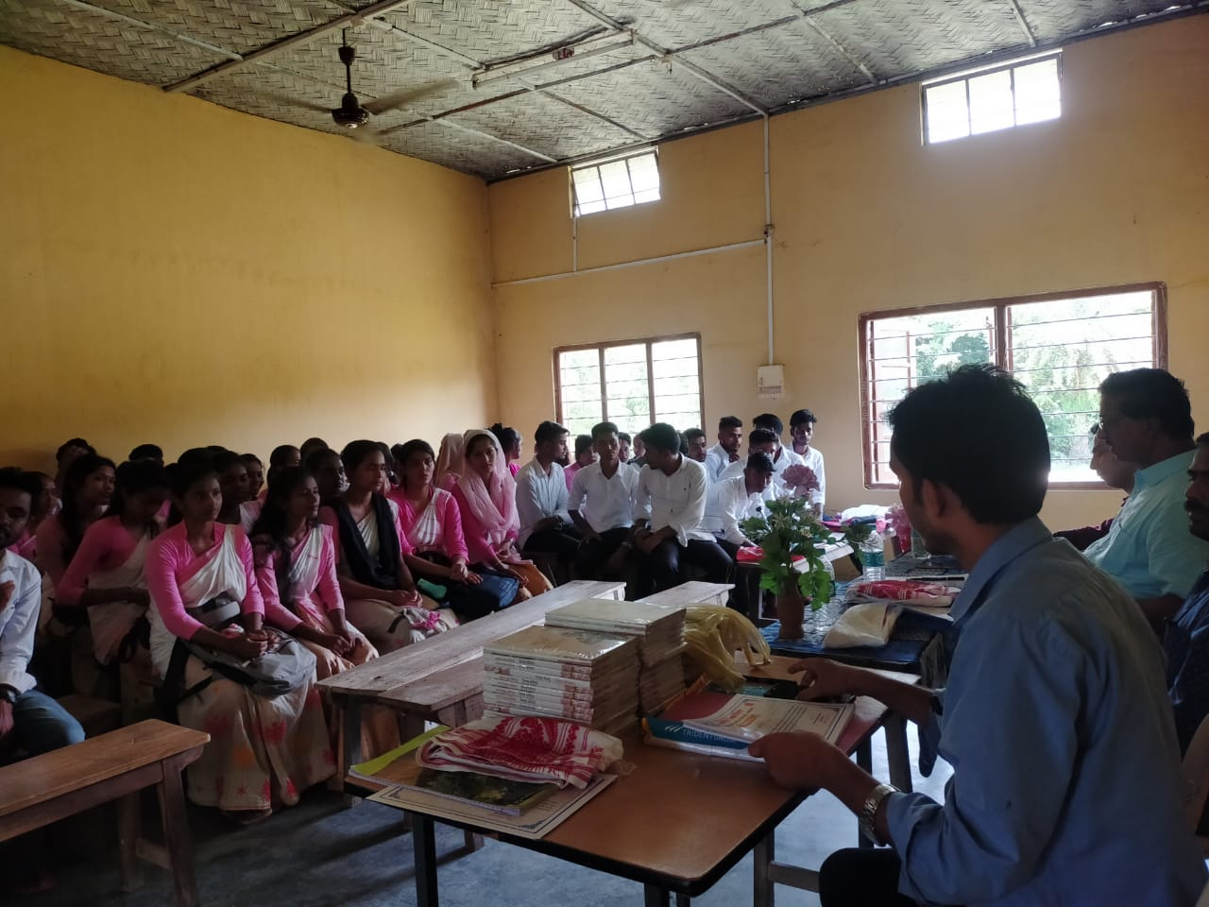
(Noor Alam)
HoD, Dept. of Political Science

Annexure 5
Departmental Activity Report
2022-23

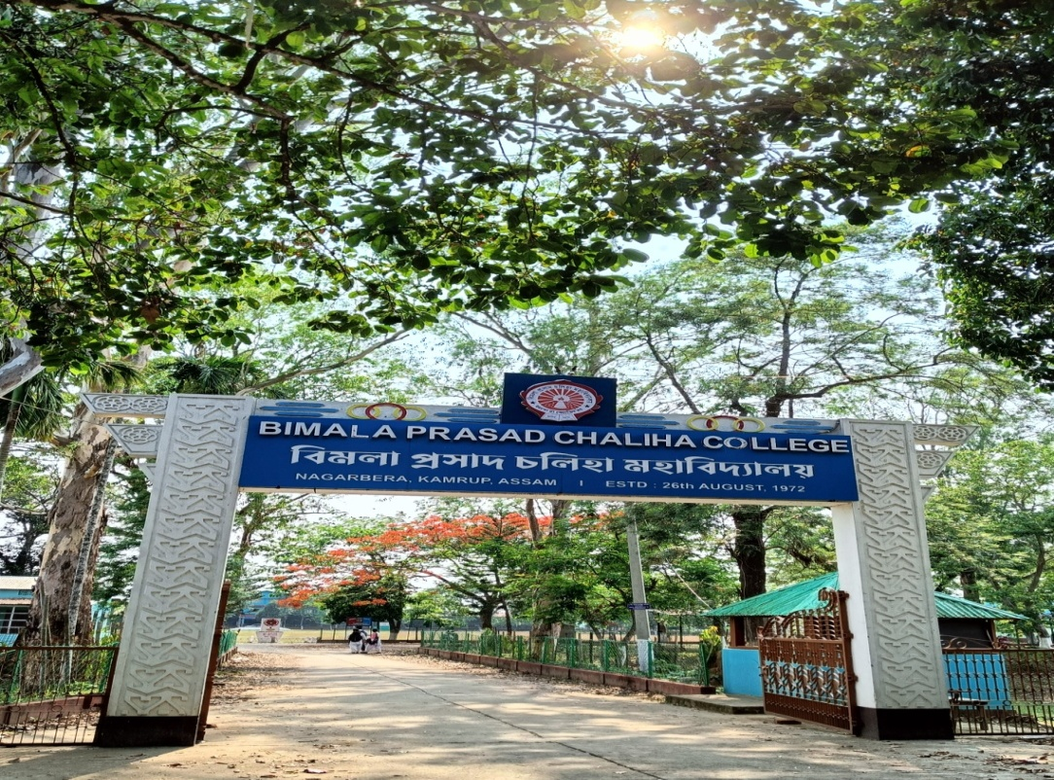
Department of Political Science
B. P. Chaliha College, Nagarbera
2022-23

- Name of the Activity: Freshman Social cum Induction Programme
Date: 14/09/2022
Venue: Hall no 1
The freshmen social cum Induction programme of Department of Political Science was held on 14th September, 2022 in the hall no 1 of the college premises. The session started at 11 am with a chorus sung by the students of the department. Mr Noor Alam, HoD, chaired the session.

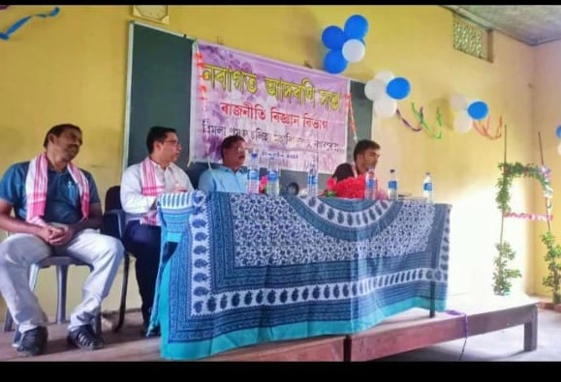

Lectures have been given by Dr Diganta Kalita and Dr Anjan Jyoti Borah on the curriculum of BA in Political Science and elaborated the course objectives, syllabuses before the fresher’s.

- Name of the Activity: Alumni Meet
Date: 26/10/2022
Venue: Room no 19
Department of Political Science organised a Alumni Meet on 26th October, 2022 at Room no 19 in the College premises. Mr Abdul Hakim, Ex HoD of department of Political Science inaugurated the ceremony. Mr. Dayananda Kr Das, Ex HoD, Department of Political Science, B. P. Chaliha College in his lecture remembered the golden days of his college life. After that all the alumni present in the meeting expressed their memories and became nostalgic. The meeting has end with the vote of thanks given by Dr. Diganta Kalita, Asststant Professor, Department of Political Science, B. P. Chaliha College.

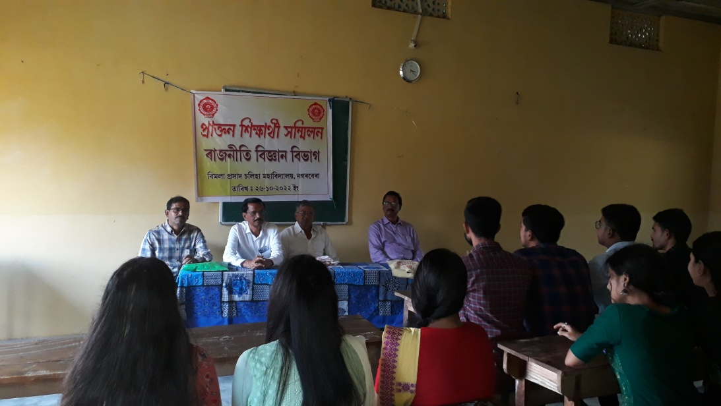
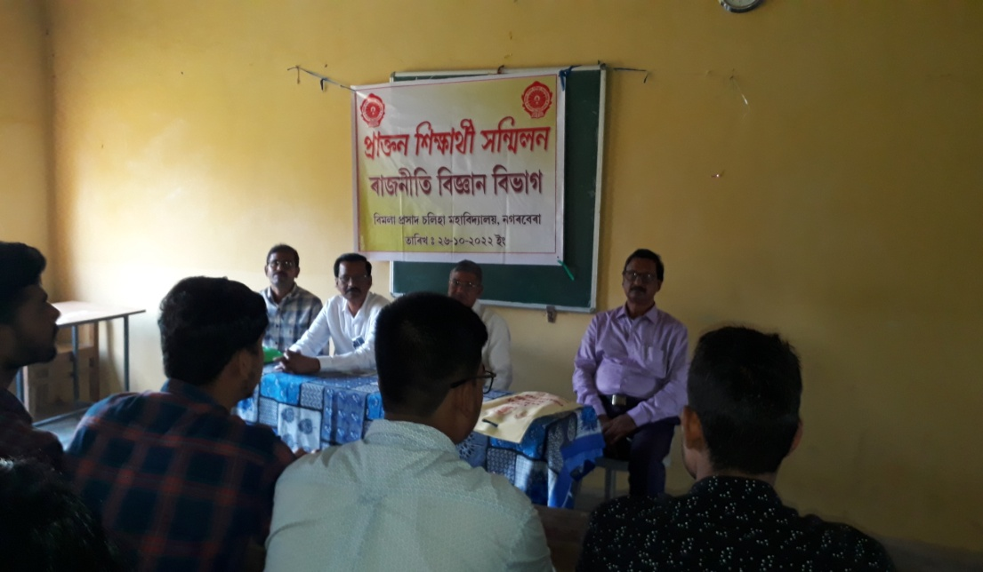

- Name of the Activity: Celebration of Constitutional Day, 2022
Date: 26/11/2022
Venue: Hall no 1
Department of Political Science, B. P. Chaliha College celebrated Constitution Day to mark the anniversary of the adoption of the constitution of India. The faculties and the students of the department highlighted the contribution of framers of the Indian constitution with respect to prominent values and fundamental rights. Following activities are conducted: i) Speech by the students ii) Preamble reading

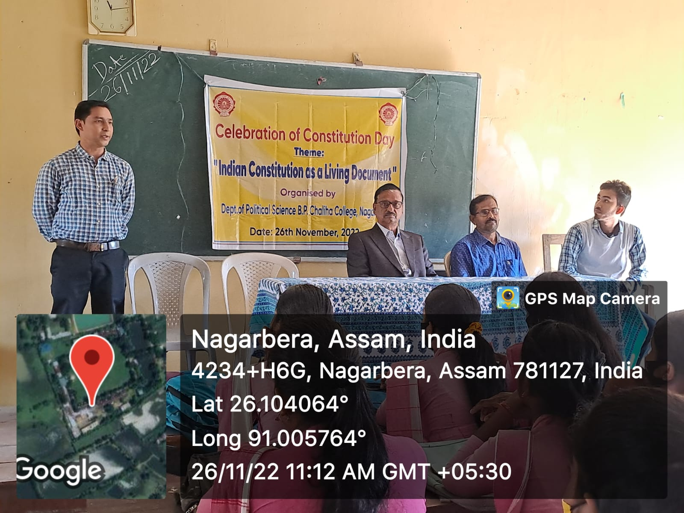
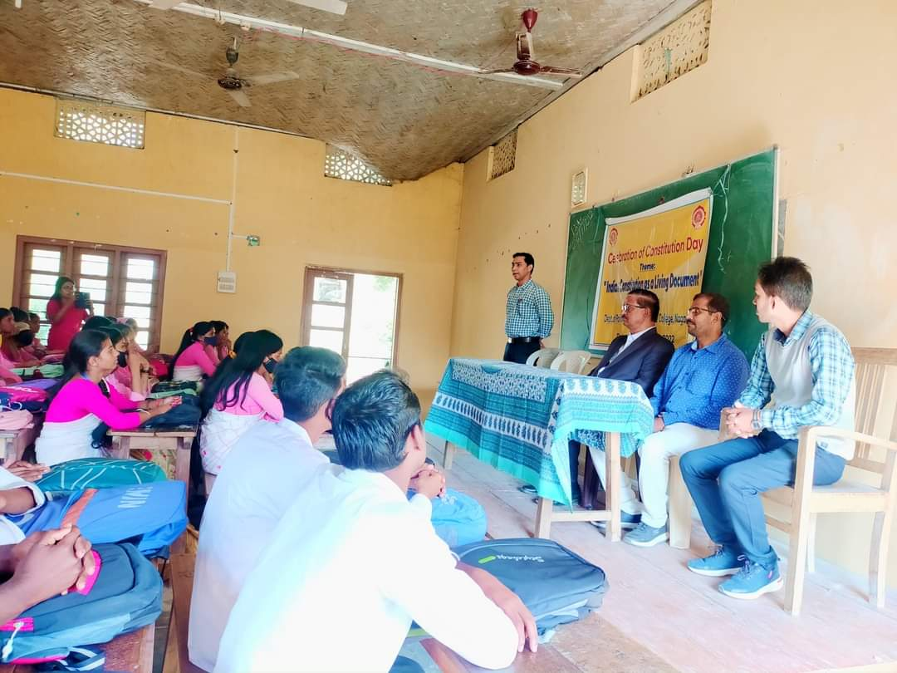

- Name of the Activity: Online lecture series 1: Lecture on “Unsung Heroes of Indian Freedom Struggle”
Date: 28/02/2023
An online lecture was organised by the Department of Political Science in association with IQAC, B. P. Chaliha College. Dr Aniruddha Kumar Baro, an eminent scholar and Assistant professor from Pandu College, Guwahati presented the lecture on “Unsung Heroes of Indian Freedom Struggle”. Dr Baro has been a keen observer and researcher on Indian Politics. He spoke for about 90 minutes before the students and faculties gathering of more than 100.
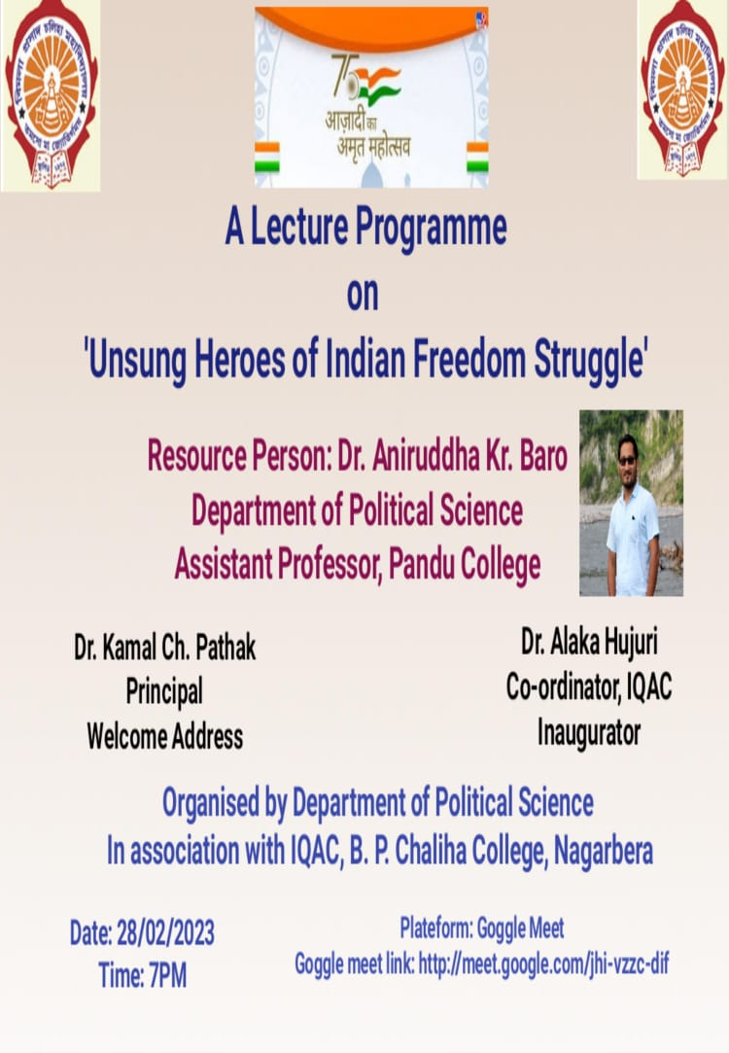
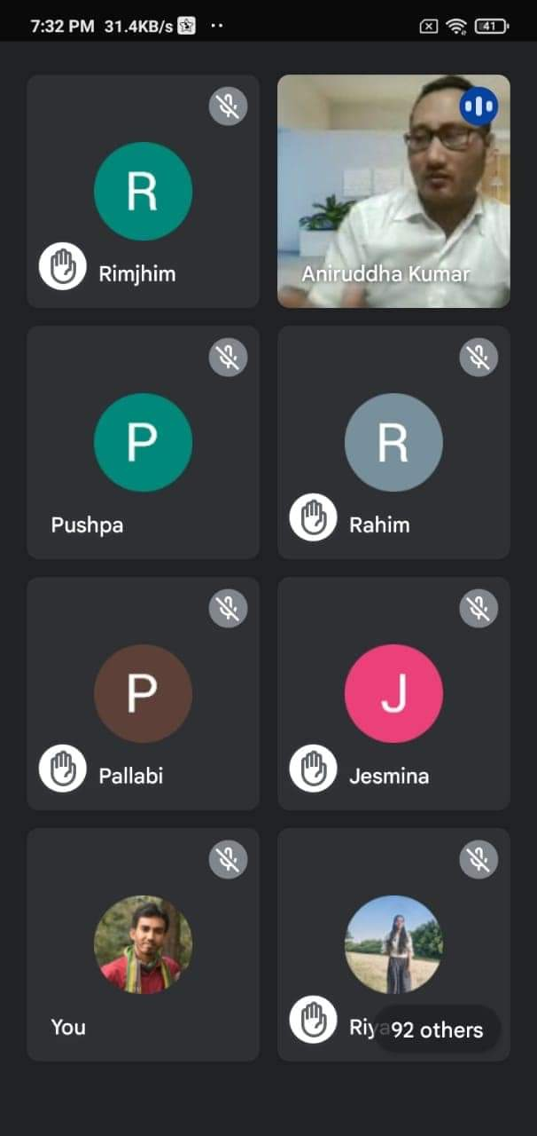
- Name of the Activity: Debate Competition on the topic The Ongoing G-20 Summit in India will enhance India’s Importance internationally.
Date: 17/03/2023
Venue: Hall no 1
The debate competition was organised by Department of Political Science in collaboration with Debate Club, B. P. Chaliha College under the guidance of faculty coordinator Dr. Diganta Kalita. The event was conducted at hall no 1. The motion of the debate was 'The ongoing G-20 Summit, 2023 in India will enhance Indias Importance Internationally'. The participants were Kuudus Ali, Surhab Ali, Ashraful Islam, Sofiqul Ali, Rejaul Karim, Leeza Talukdar, Chinmoy Medhi, Aminul Islam, Shah Alam Ali, Ahajudin, Hiyamonim Pathak and Moon Ali. Winners of the competition were Sofiqul Ali, Hiyamoni Pathak and Leeza Talukdar.
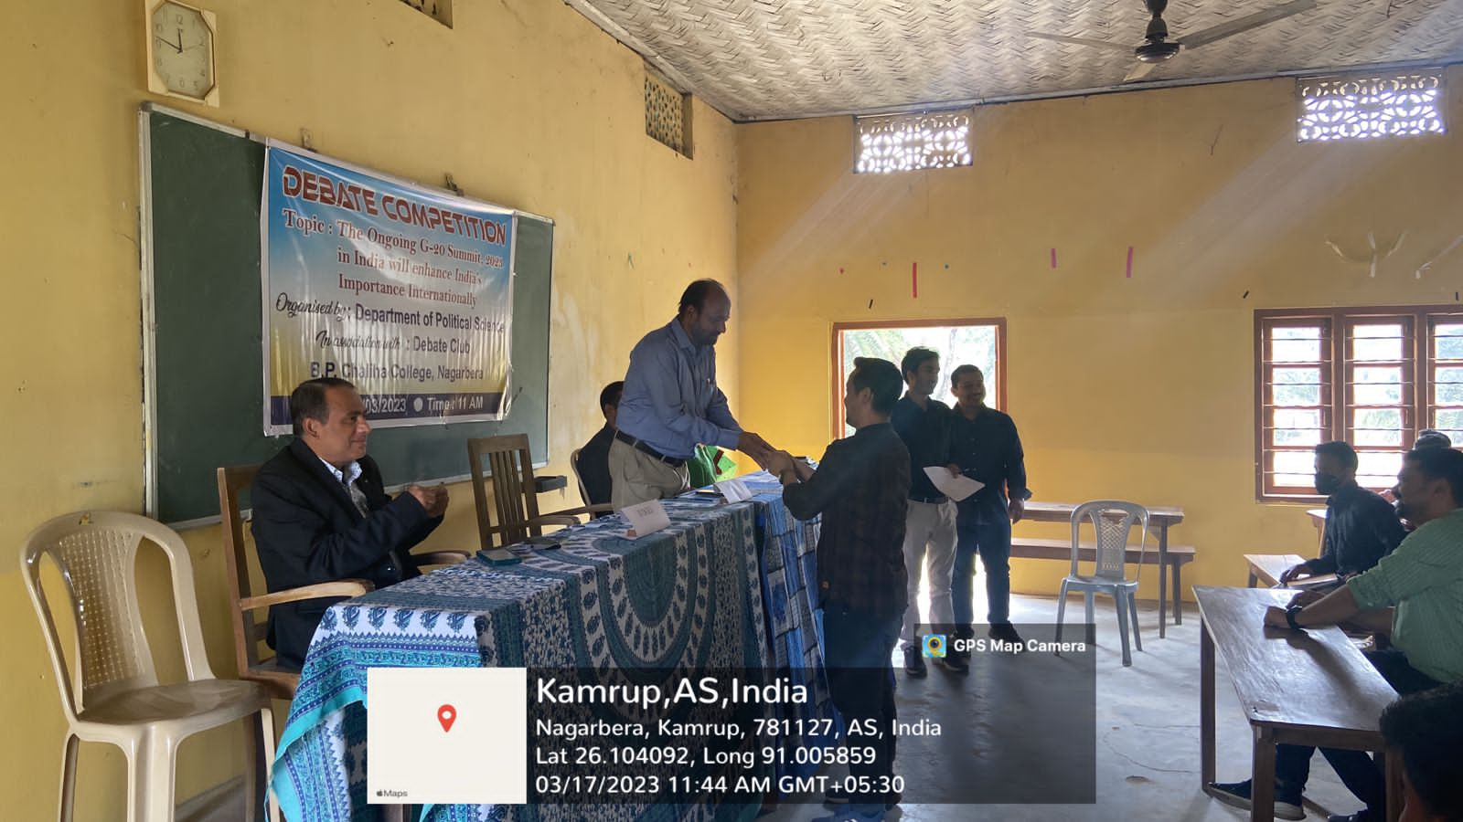
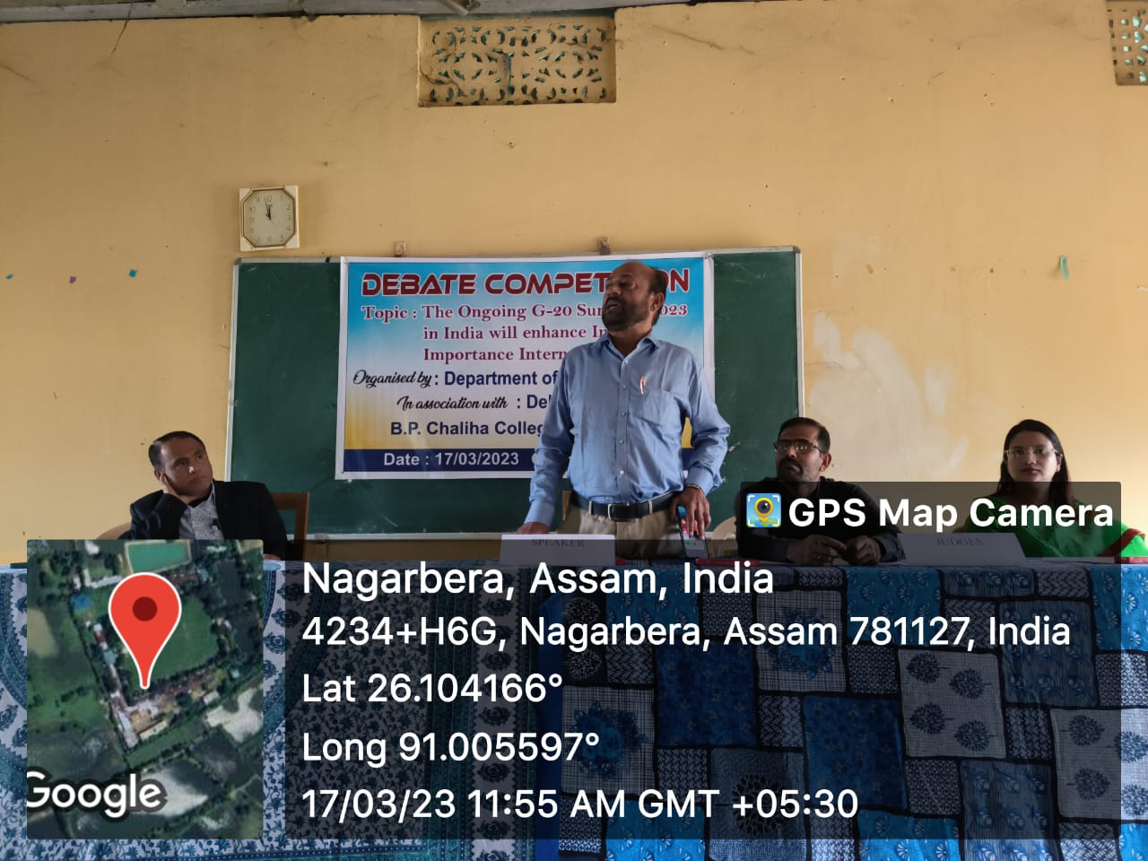

- Name of the Activity: Educational Trip to RAJBARI and MADHUPUR SATRA, WESTBENGAL
Date: 22/03/2023
One day educational trip was organised by the department of Political Science to Rajbari and Madhupur Stra, West Bengal on 22/03/2023. Total participants were 49 out of which 45 were students. The objective of this study is to identify the opportunities of host community and to explore the heritage of Rajbari and Madhupur Satra.
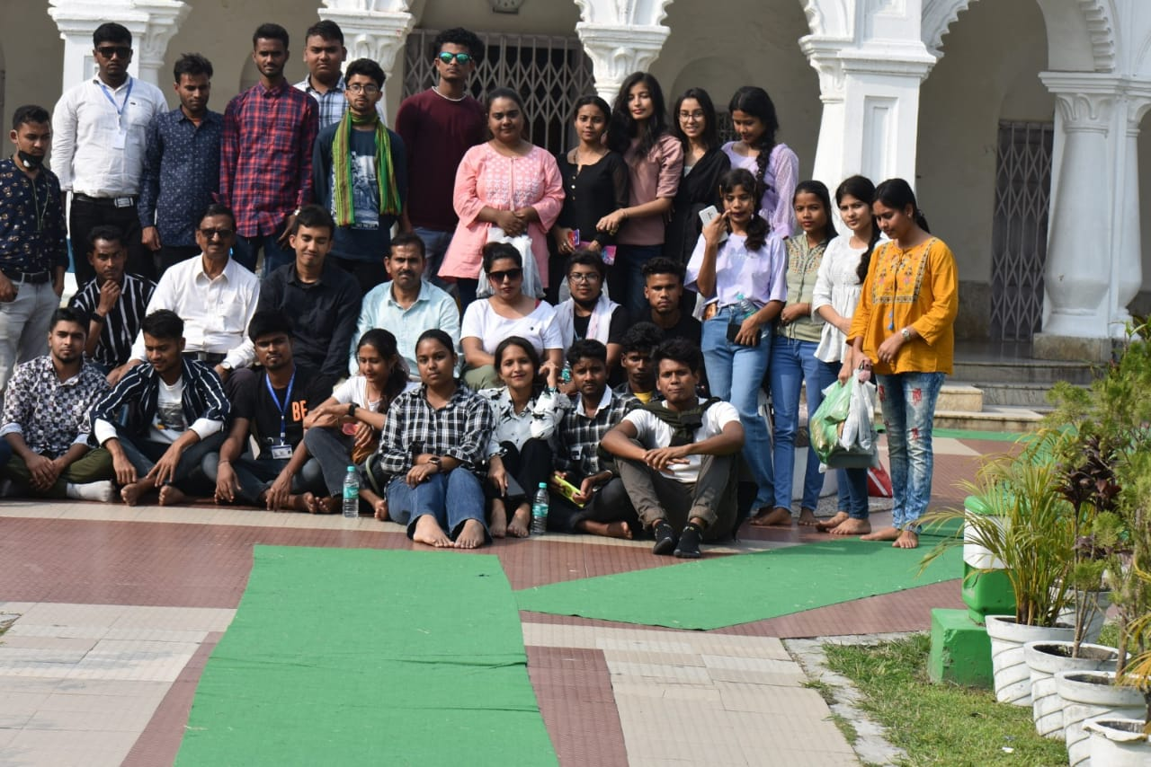
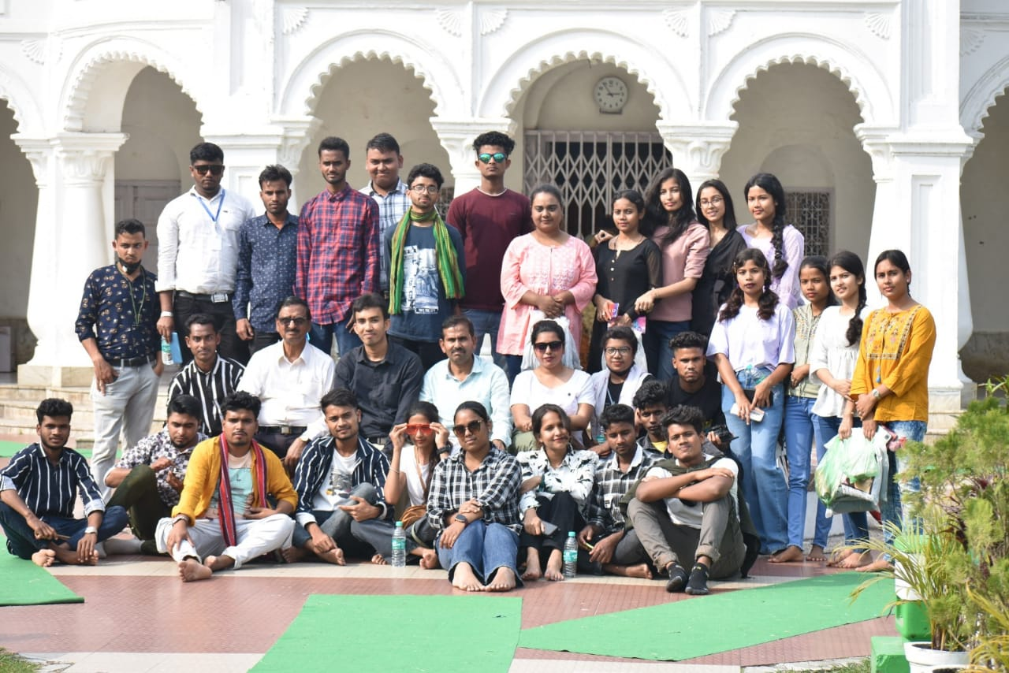

- Name of the Activity: Brainstorming Session on Transition from college to Career
Date: 08/04/2023
Venue: Seminar Hall
A brainstorming cum counselling session was jointly organised by department of Political Science, Department of History and Department of English on 08/04/2023. The event was on the topic Transition from College to Career. Resource person was Dr Kamal Kalita, State IT Officer, Panchayat and Rural Development Department, Assam Government.
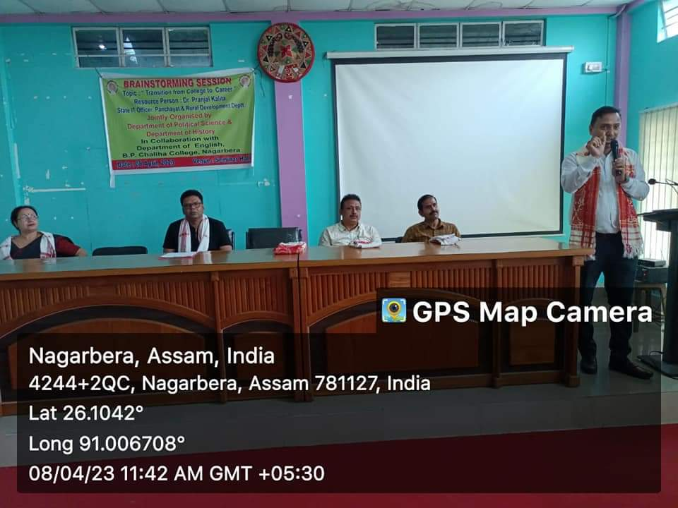
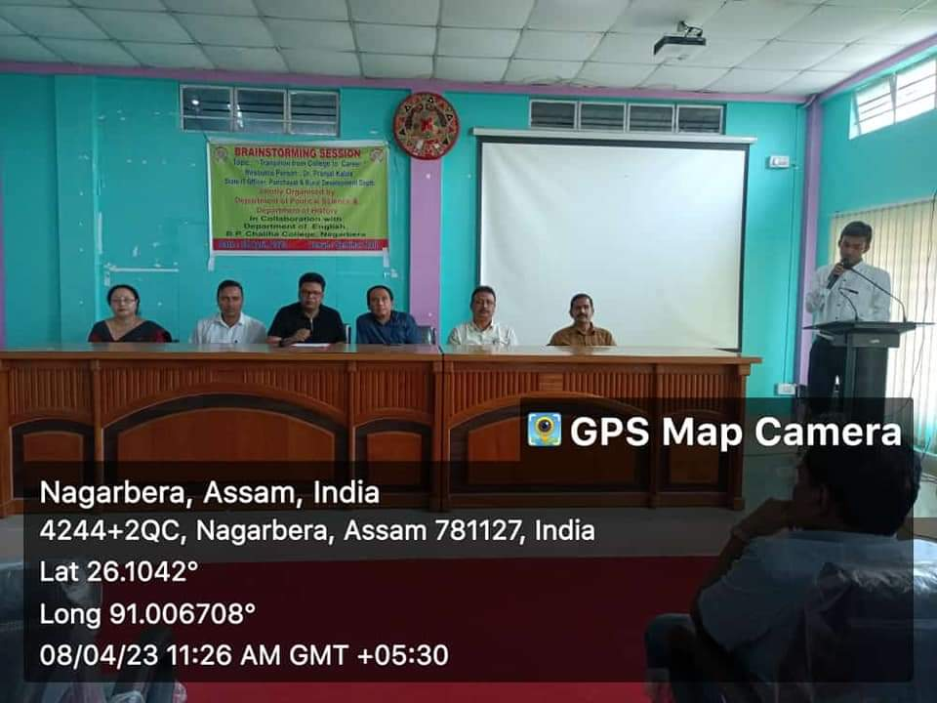

- Name of the Activity: Lecture on Higher Education opportunities for Political Science Students in India and Abroad.
Date: 28/04/2023
Venue: Google meet
Resource person: Dr Chuchengfa Gogoi, Assistant professor, North Lakhimpur University

A lecture programme was organised by the Department of Political Science in association with IQAC, B. P. Chaliha College. Dr Chuchengfa Gogoi, an eminent scholar and Assistant professor from North Lakhimpur University, Assam presented the lecture on “Higher Education Opportunities for Political Science Students in India and Abroad”. He spoke for about 60 mins before a student and faculties gathering of 100.

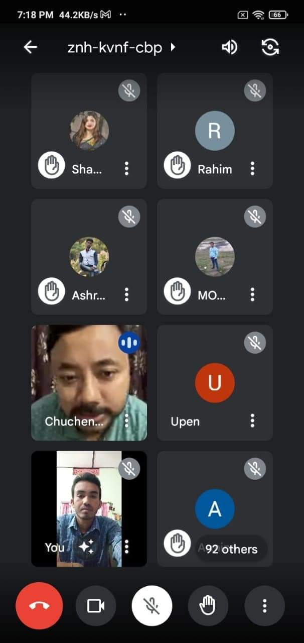

- Name of the Activity: Seminar on Democracy and Nationalism in India
Date: 25/04/2023
Venue: Seminar Hall
In the series of various academic activities departmental seminar was presented by the Department of Political Science, B. P. Chaliha College, on 25th April, 2023. The theme of the seminar was ‘Democracy and Nationalism in India.' The Welcome address has been given by Dr Kamal Ch. Pathak, Principal, B. P. Chalihga College. Chief Guest was Mr. Noor Alam, Retired HoD, Department of Political Science. The presentation of topic entitled “Democratic Decentralisation in India”, was done by Nilakhshi Kalita, a sixth semester students of Dept of Political Science. Following her eight numbers of papers presented in the seminar.
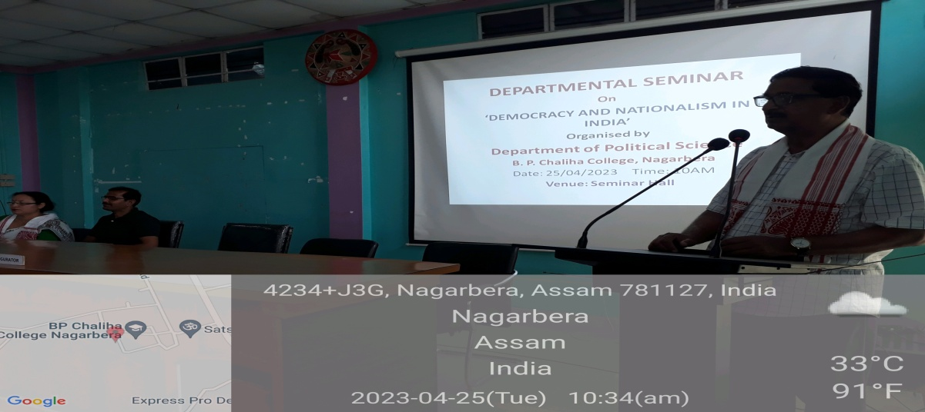
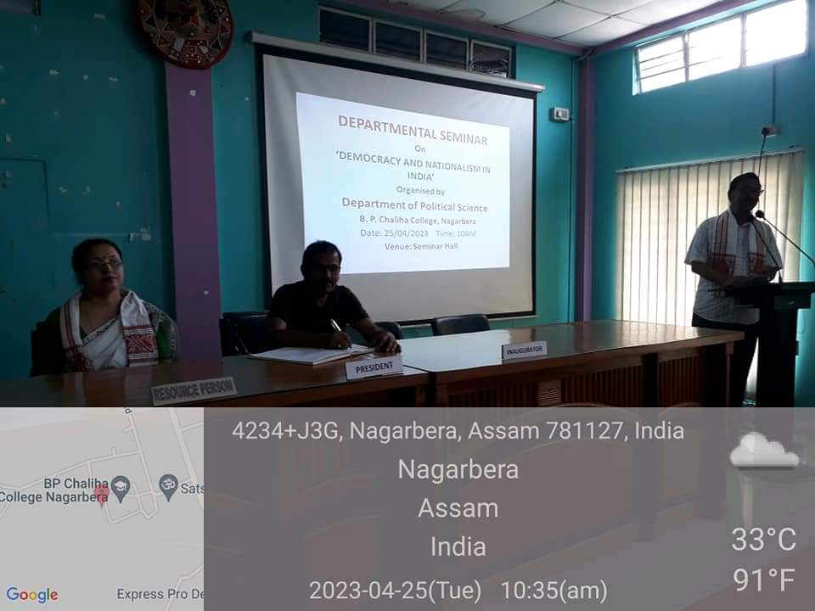

- Name of the Activity: Seminar on Panchayati Raj and Rural Development in Assam
Date: 08/05/2023
Venue: Seminar Hall
Departmental seminar on ‘Panchayati Raj and Rural Development in Assam’ was organised by Political Science study Forum, Department of Political Science on 08/05/2023 at seminar hall of the college. The Inaugural Session started at 10 am with the welcome address given by Dr Diganta Kalita. Chief Guest was Dr. Kamal Ch. Pathak, Principal, B. P. Chaliha College. The technical session started at 10.30 AM and 9 papers had been presented by the students of the department.
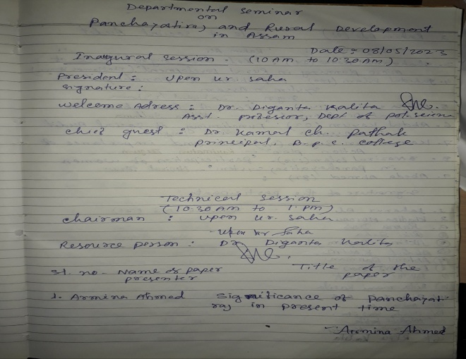
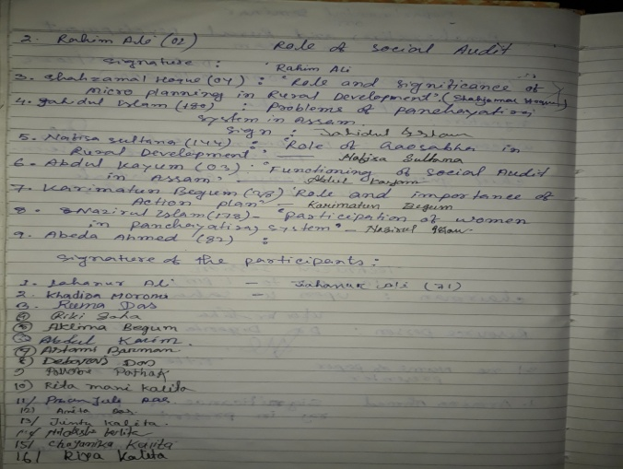

- Name of the Activity: Farewell cum Counseling Programme
Date: 28/04/2023
Venue: Hall no 1
The farewell cum Counseling programme for the final year students held on 28/04/2023 at Hall no 1 in the college premises. The programme was started with a chorus sung by the students. Dr Diganta Kalita and Mr Upen kumar Saha delivered counseling lecture about the future career of the students.
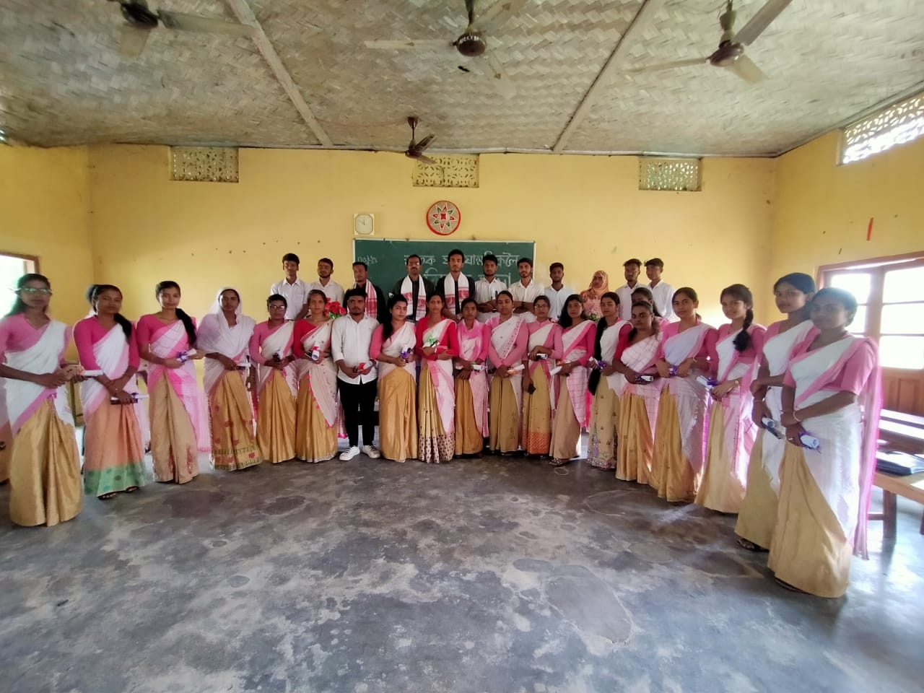
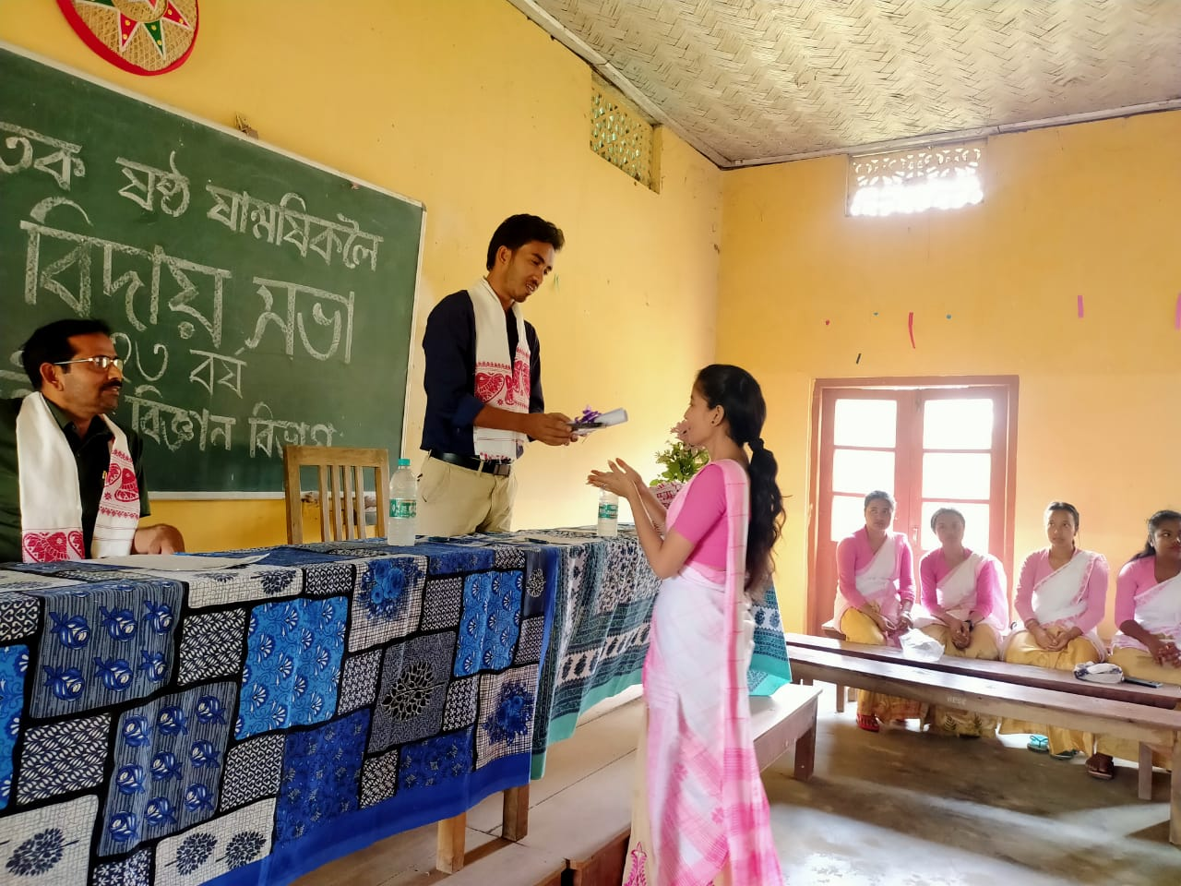

- Name of the Activity: Awareness Programme on Voting Rights
Date: 31/05/2023
Venue: Hall no 1
An awareness programme on Voting Rights was organised by the department of Political Science on 31st May 2023. A lecture on the ‘Voting Rights and its importance' has been delivered by Mr Upen Kr Saha, HoD, Department of Political Science and Dr. Diganta Kalita, Assistant Professor, Department of Political Science. Mr. Bidyut Dutta, HoD, Department of Assamese and Mr Gokul DAS, Guest Faculty, Department of Political Science was present in the programme.

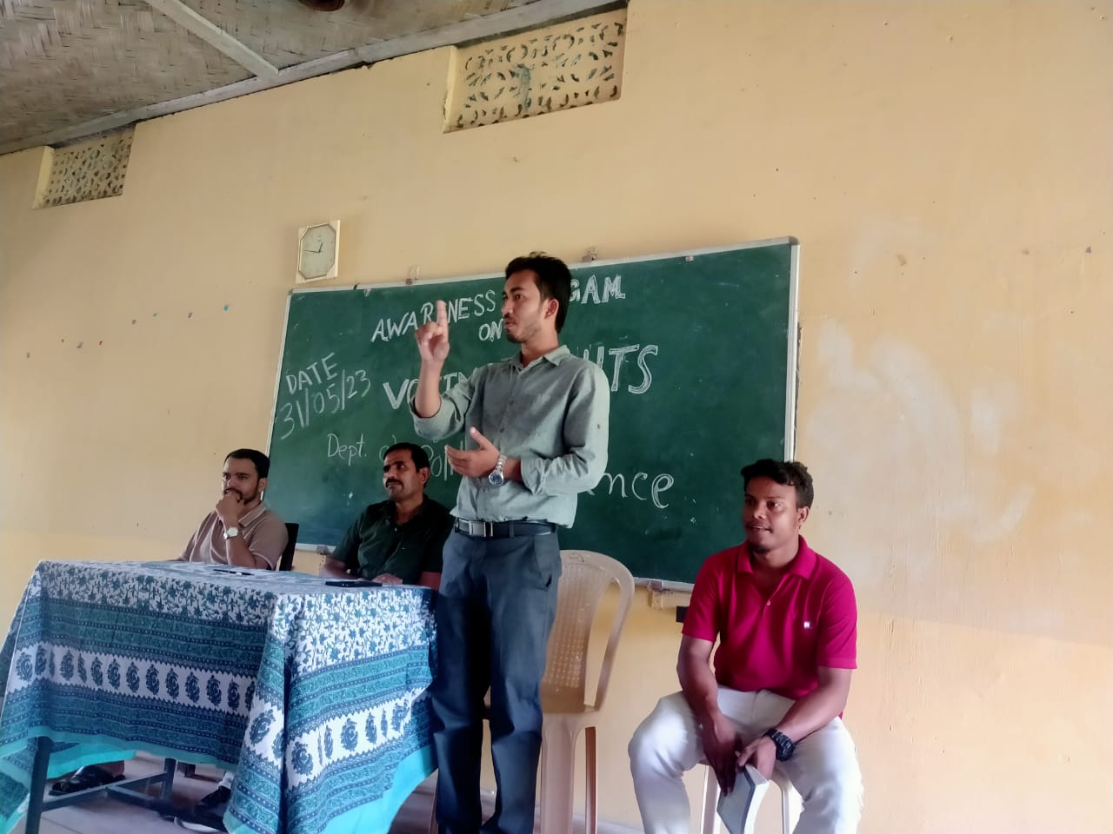

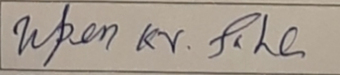
(Upen Kumar Saha)
HoD
Department of Political Science

