Programme Report
BSE Investor Awareness Programme
Topic: Principles of Investing in the Securities Market
Date: February 18, 2026
An Investor Awareness Programme on the topic “Principles of Investing in the Securities Market” was successfully organized on February 18, 2026, by the Department of Economics, B. P. Chaliha College, Nagarbera, Kamrup, Assam, in collaboration with BSE Ltd, to enhance financial literacy and promote informed investment practices among students.
The programme was conducted in online mode, enabling wider participation of students. The session was smoothly hosted by Ms. Minakshi Baro, Assistant Professor, Department of Economics.
The programme began with a welcome address delivered by Mr. Anshuman Saikia, Head of the Department (HoD), Department of Economics, who highlighted the importance of financial literacy and the relevance of such awareness programmes for students in today’s dynamic financial environment.
The resource person for the programme was Ms. Marina Jose Kanjikal, Resource Person, BSE Ltd. She holds a B.Sc. in Mathematics and an MBA in Finance from Mahatma Gandhi University. With extensive experience in investor education, she has been conducting Investor Awareness Programmes across India since 2014 and delivers more than 120 sessions annually, reaching students from diverse parts of the country.
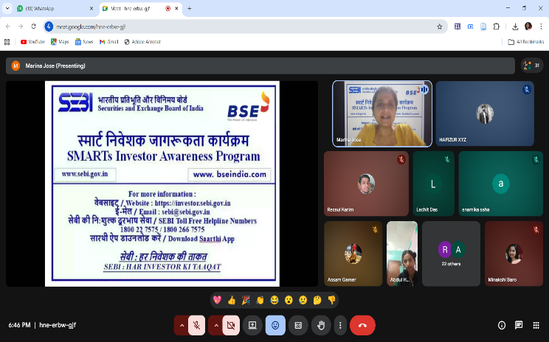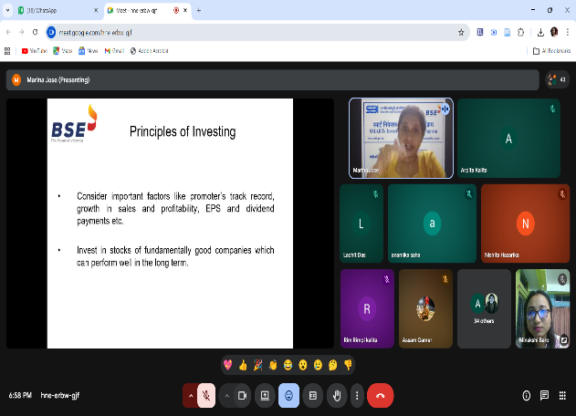
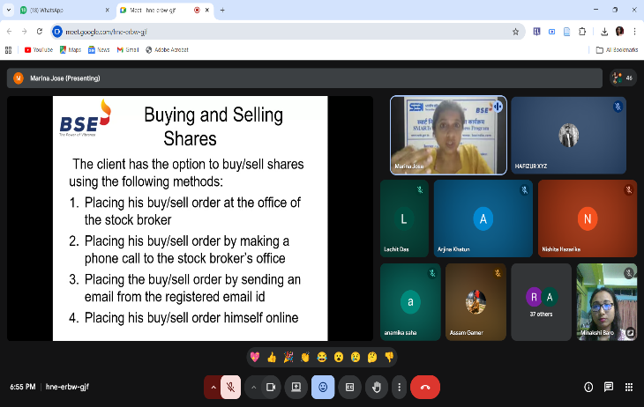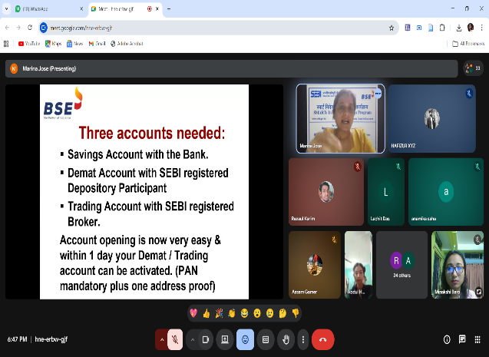

During the session, Ms. Kanjikal provided a comprehensive and hands-on explanation of key concepts, including:
- Basics of the securities market
- Principles of investing
- Risk and return analysis
- Importance of diversification and financial planning
- Awareness about fraudulent investment schemes
The session was highly interactive and engaging, with active participation from students. The practical approach adopted by the resource person made the session more effective and insightful.
The programme concluded with a Vote of Thanks delivered by Dr. Alaka Hujuri, Associate Professor, who expressed sincere gratitude to the resource person, BSE Ltd, the respected Principal, faculty members, and all participants for contributing to the success of the event.
Overall, the programme proved to be highly informative and beneficial, significantly enhancing the financial awareness of students and encouraging them to become responsible and informed investors.

