Lecture Programme At Hekra Higher Secondary School

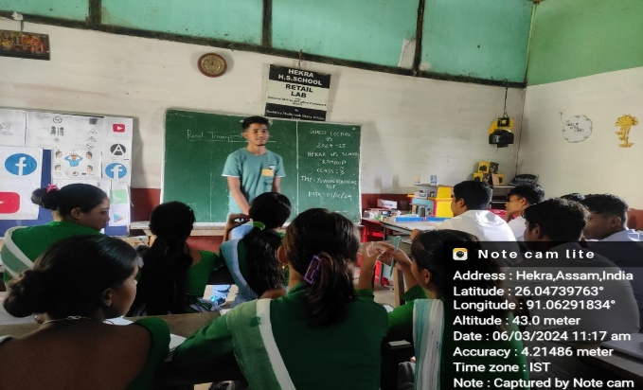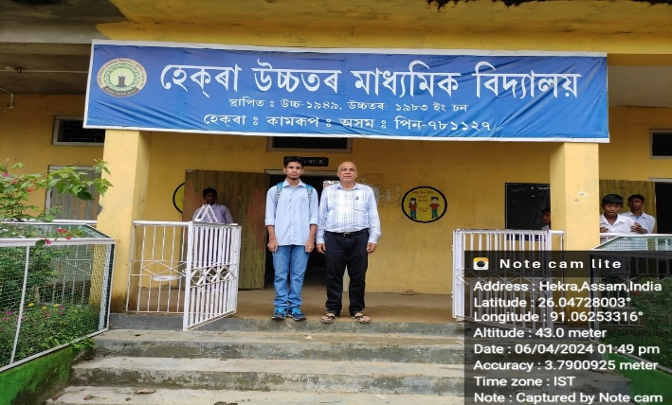

A lecture program was conducted at Hekra Higher Secondary School on 03/06/2024 and 04/06/2024. Commerce Department student discussed few topics with the students of class 9, 10 in the two day programme.

