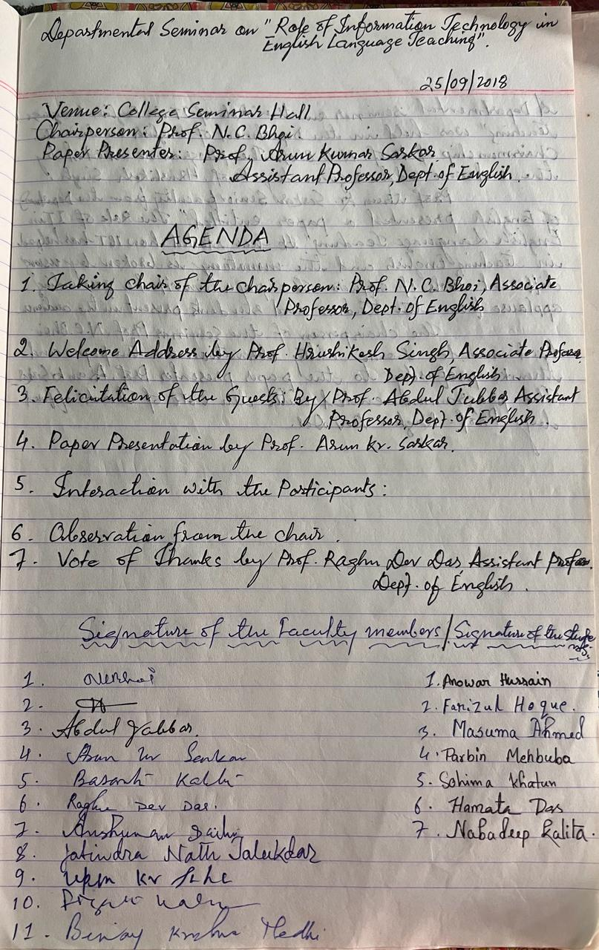
Departmental seminar on role of IT in English Language Teaching. The proggramme was held on 25th of December, 2018. Prof. Nirmal Chandra Bhoi was the chairperson. Prof Arun Kr Sakar presented the paper on the role of IT in English Language Teaching. Seven students participated along with eleven faculties

