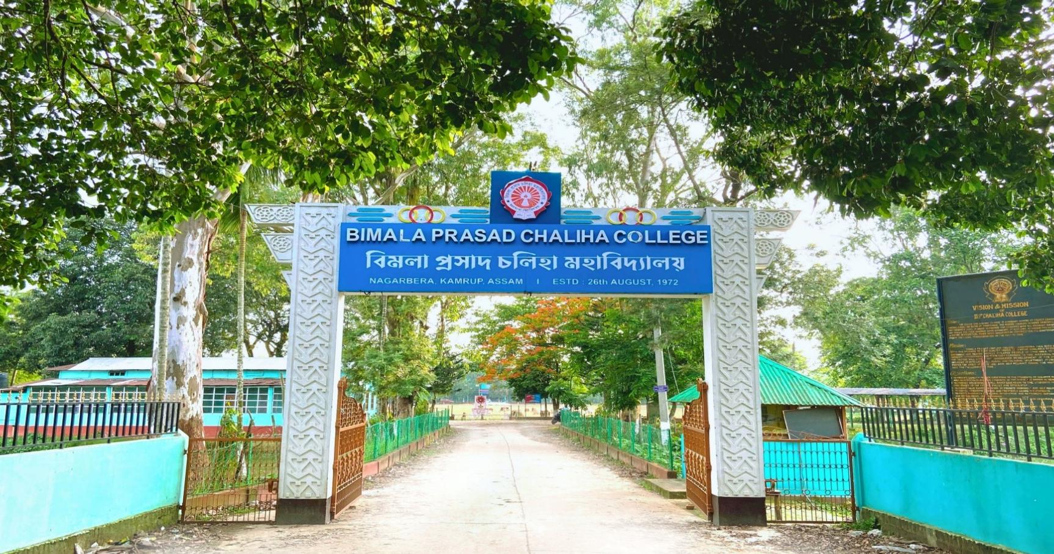



B.P. CHALIHA COLLEGE

Department of english

AEC
COURSE OBJECTIVE, LEARNER OUTCOME




SL...  NO. | SUBJECT | COURSE  CODE | COURSE  TITLE | OBJECTIVE | EXPECTED LEARNER  OUTCOMES
1. | AEC | ENG-AEC-151 | ENGLISH COMMUNICATION-I | The objective of this paper is to equip students from all disciplines with the basics of English Communication skills both written and spoken in a variety of real-life situations. | The graduates are expected to acquire a comprehensive knowledge of the theory and practical application of communication, especially in English and to develop communication skills that are crucial to their personal, social and professional interactions. Graduates will also be able to develop complex problem-solving abilities, critical thinking and analytical reasoning.

