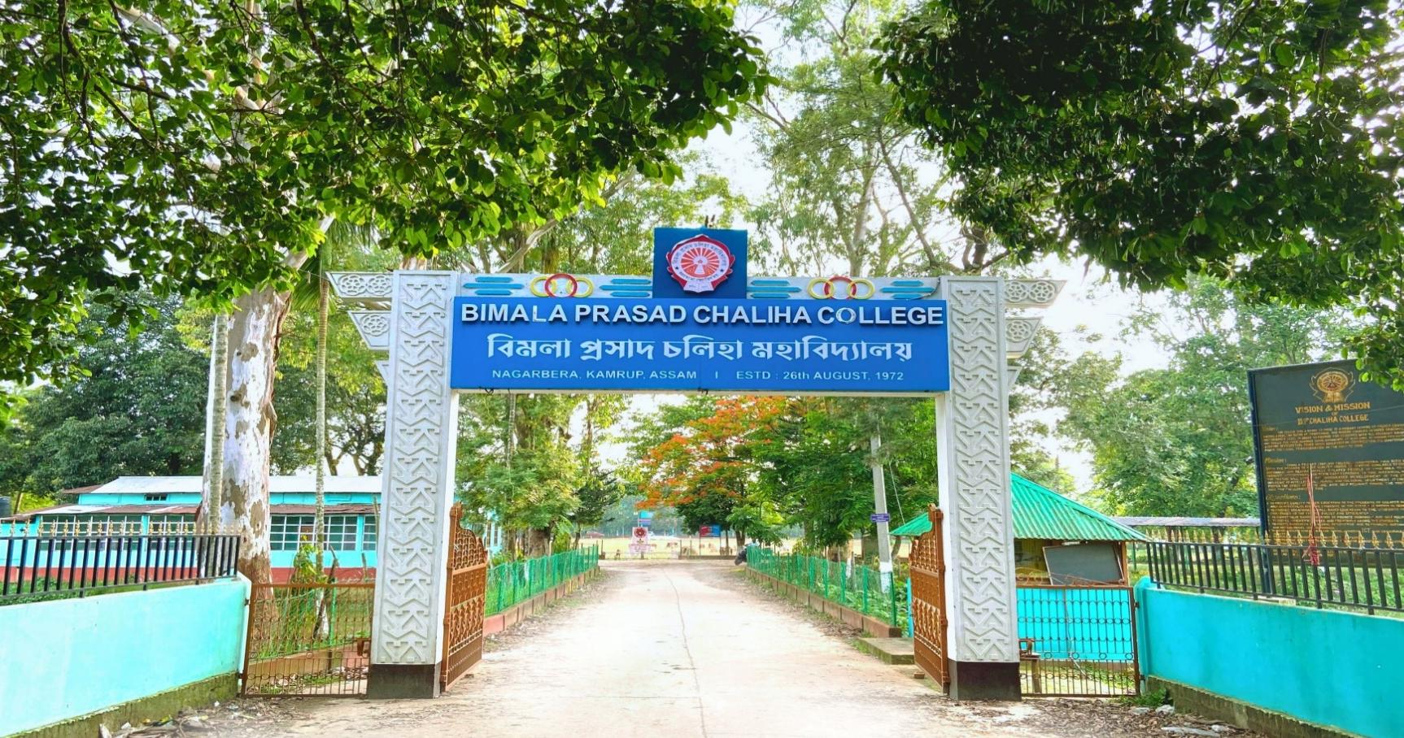

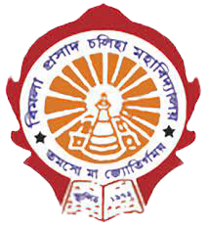

B.P. CHALIHA COLLEGE

Department of english

COURSE OBJECTIVES, LEARNER OUTCOME
SKILL ENHANCEMENT COURSE




SL  NO. |  | COURSE  CODE | COURSE  TITLE | OBJECTIVE
 |  | SEC0203703 | ELT SKILL-II | The objective is to prepare students with hands on knowledge of English language teaching by using ICT and other tools. | The students will able to cope up with the modern teaching of English language.

