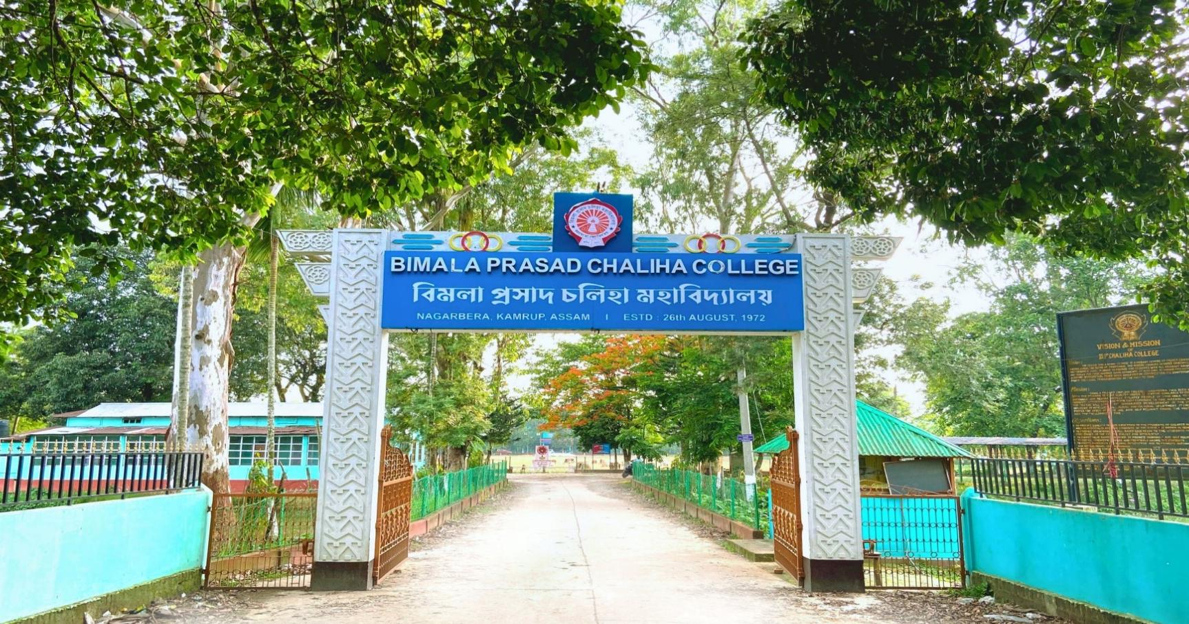



B.P. CHALIHA COLLEGE

Department of english



COURSE OBJECTIVE, LEARNER OUTCOME
FYUGP 1st SEM and 2nd SEM
SL  NO. | SUBJECT | COURSE CODE | COURSE TITLE | OBJECTIVES | EXPECTED LEARNER OUTCOMES
1. | ENGLISH | HC-1016 | ENGLISH LITERARY AND SOCIAL HISTORY | The objective of this paper is to introduce students to students to English literary and social history in terms of ideas and events that bear on the production of texts embarked for study of the basics of English literature. | The students will be expected to familiarize themselves with the literary and social aspirations of English as revealed in its literature through the different periods and ages.
2. | English | HC-2016 | FORMS, GENRES And CONCEPTS Of ENGLISH LITERATURE | The objective of this paper is to introduce students to the forms, genres and concepts of English Literature. | The students will be expected to familiarize themselves with the themes, ideas and different generic dimensions of literary writing and practice.

