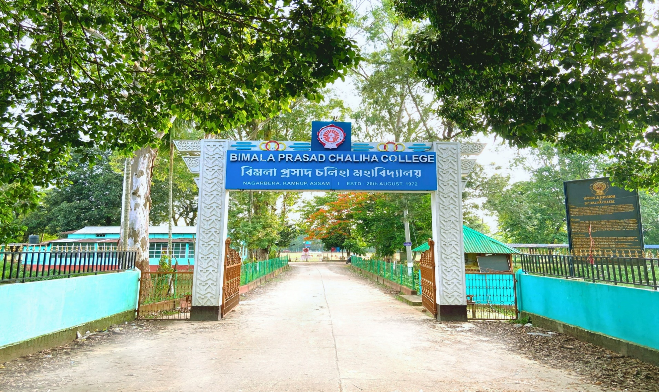



B.P. CHALIHA COLLEGE

Department of english




CHOICE BASED CREDIT SYSTEM
COURSE OBJECTIVE, LEARNER OUTCOME
DEPARTMENT OF ENGLISH
B. P. CHALIHA COLLEGE
NAGARBERA-KAMRUP

SL. NO. | SUBJEC T | COURSE CODE | COURSE TITLE | OBJECTIVE | EXPECTED LEARNER OUTCOMES
1 | ENGLISH | ENG-HC-1016 | Indian Classical Literature | The objective of this paper is to introduce students to a selection of literatures of India in English translation. Indian Classical Literature offers a rich and diverse canvas that spans across genres like drama, poetry, the epic narrative as well as short fictional fables, to name a few, it is essential that students studying English literature are familiar with at least a few of these. | The students are encouraged to think laterally about literatures of the world, and the possibility of cultural exchange.
1 | ENGLISH | ENG-HC-1026 | European Classical Literature | The objective of the paper is to focus on Classical writing in Europe, it saw the emergence of traditions that cut across many genres, which included poetry, theatre, and general discourses. The emergence of the theatre depicted widely divergent compositions by Sophocles and Plautus respectively show the consolidation of a rich cultural discourse. | The learners are made familiar with the representative texts belonging to the Classical Period. They are made aware on epic and drama, writers such as Horace, drawing attention to the purposefulness of the creative study.
1 | ENGLISH | ENG-HC-2016 | Indian Writing in English | This paper on Indian Writing in English introduces students to the historical development of this body of writing- the challenges faced by early writers, the growing sense of accomplishment in the writing of different forms and the interpretation of individual and collective experience in colonial and postcolonial India. The objective of the paper aims at Introducing students to the field of Indian Writing in English. It also gives a historical overview of the development of various literary forms. It understands how each author creatively uses his or her chosen literary form | The expected learner outcome is to develop familiarity with the issues of politics of language and gender, nationalism and modernity pertaining to pre and post-Independence India that have been responsible for the emergence of Indian English literature. The students are also made aware to discuss critically the use of literary forms of the novel, poetry and drama by Indian English writers in distinctive ways against Indian historical and cultural contexts. The students understand the place of English Writing in India in the larger field of English Literature
1 | ENGLISH | ENG-HC-2026 | British Poetry and Drama: 14th to 17th Centuries | This paper aims to familiarize the students with the two major forms in British literature from the 14th to the 17th centuries – poetry and drama, apart from acquainting them with the contexts that generated such literatures. The larger contexts of the Renaissance, the nature of the Elizabethan Age and its predilections for certain kinds of literary activities, and the implications of the emergence of new trends will be focused in this paper. | The student’s outcome is that they are made familiar with the British poetry and drama. They are highlighted with the seminal issues and preoccupations of the writers and their ages as reflected in these texts.
1 | ENGLISH | ENG-HC-3016 | History of English Literature and Forms | This paper introduces students to the History of English Literature and the major literary forms. It adopts a chronological approach to the study of poetry, drama, fiction and non-fictional prose, showing the development of each form as it moves through the various periods of English literature and its expansion into global English writing. The main objective of the paper is to prepare the ground for the detailed study of the literature featured in subsequent papers and give a strong historical sense of literary development. | The learner’s outcome is to acquire a sense of the historical development of each literary form. The students gain understanding of the contexts in which literary forms and individual texts emerge. The learners. The learners learn to analyze texts as representative of broad generic explorations.
1 | ENGLISH | ENG-HC-3026 | American Literature | This paper seeks to acquaint the students with the main currents of American literature in its social and cultural contexts. The texts incorporated in the paper are a historical reflection of the growth of American society and of the way the literary imagination has grappled with such growth and change. | The study of this paper, acquaints the students with the American society in its evolutionary stages from the beginnings of modernism to the present as well as with exciting generic innovations and developments that have tried to keep pace with social changes.
1 | ENGLISH | ENG-HC-3036 | British Poetry and Drama: 17th and 18th Centuries | This paper aims to familiarize the students with British literature in the 17th and 18th centuries, a time-period which sees the emergence and establishment of greatly diverse kinds of writings. The selected texts may encourage the students to look at the economic, political and social changes in (primarily) Britain during this period, such as the shifts from the Puritan Age to the Restoration and Neoclassical periods. | The learners are made familiar with the larger contexts that generated such literatures as well as the possible impacts of the literature on society. They are made aware with the significance of the scientific revolution during this period in relation to the literary productions.
1 | ENGLISH | ENG-HC-4016 | British Literature: The 18th Century | This paper aims to familiarize the students with British literature in the 18th century. A very interesting age in which reason and rationality dominated, this age saw the publication of some of the best novels and works of non-fictional prose and poetry in the English language. Though it was not predominantly an age of drama yet one cannot but pay attention to the few plays of the century. | The students are made that women writers were part of the literary movement. They are made aware about the prospects and understanding of British Literature.
1 | ENGLISH | ENG-HC-4026 | British Romantic Literature | The nineteenth century begins with the triumph of the Romantic imagination, expressing itself most memorably in the poetry of Blake, Burns, Wordsworth, Coleridge, Shelley, and Keats. The poetry of the age fashions itself partly in revolt to the spirit of the previous age, with very different ideas about the relationship between humans and nature and the role of the poet taking hold. | The learners are made aware about the works of major Romantic poets which address these issues, enabling students to appreciate the essence of the Romantic vision. In addition they will read that remarkable oddity, Frankenstein, a novel that also illuminates Romanticism from another angle.
1 | ENGLISH | ENG-HC-4036 | British Literature: The 19th Century | The paper aims to familiarize the students with the middle and later parts of the 19th century novel coming into its own, although Jane Austen has already established the prestige of the novel form through her incisive explorations of the complexity of human motive and conduct, especially in their worldly affairs. | The texts chosen will expose the students to the ground-breaking efforts of the poets as well to the works of fiction writers who manage to consolidate and refine upon the achievements of the novelists of the previous era. Austen to Rossetti represents a remarkable literary development and range of works, addressing a very diverse array of social preoccupations.
1 | ENGLISH | ENG-HC-5016 | British Literature: The 20th Century | The objective of the paper is that literary modernity can trace its roots to the works of some European writers of the 19th century, in England it is in the 20th century that the era of Modernism finds its voice in arts and literature. The works of the writers chosen for this paper are good introductions to the spirit of modernism, with its urgent desire to break with the codes and conventions of the past, experiment with new forms and idioms, and its cosmopolitan willingness to open itself up to influences coming from other shores | The paper goes beyond the High Modern period of the early century and the students will also get acquainted with the ethos of postmodernism through a reading of recent poetic and fictional works.
1 | ENGLISH | ENG-HC-5026 | Women’s Writing | This paper seeks to direct the students’ attention to nineteenth and twentieth century writings by women living in different geographical and socio cultural settings. Students will get acquainted with the situationally distinct experiences of women articulated in a variety of genres-poetry, novels, short stories, and autobiography, while the selections from Mary Wollstonecraft-the only 18th century text prescribed, will acquaint students with the ideas contained in one of the earliest feminist treatises of the western world. | Apart from an examination of the themes and styles in the prescribed texts, students will be required to engage themselves with the specificities of the contexts from which the texts emerged and also analyze the women writers’ handling of the different genres to articulate their women-centric experiences. Themes: Gender, sexual/textual politics, feminism, body, identity, class, location, voice, space, gender and narrative
1 | ENGLISH | ENG-HE-5016 | Popular Literature | Over the years popular literature has moved from the margins to earn for itself a fairly important place in the literary and critical consciousness. This paper seeks to highlight the nature of ‘popular’ literature as a genre and the critical ideas underpinning the theorization of popular literature. This will be done through a practical engagement with various texts falling under its ambit. | The learners will be made aware with the trending genre of popular literature, benefitting the students with critical ideas and theories associated with it.
1 | ENGLISH | ENG-HE-5036 | Literature of the Indian Diaspora | In the light of global literature today focusing extensively on ideas of transnationalism, exile, migration, displacement, and so on, literature of the diaspora has come to exert a strong presence in the global scene. This paper will look at the diasporic experience with particular reference to Indian diasporic writers. | The learners will understand about the diasporic sentimentality. The prospects of the diasporic authors and the nostalgic scenario.
1 | ENGLISH | ENG-HC-6016 | Modern European Drama | The paper aims at introducing students to the innovative dramatic works of playwrights from different locations in Europe, which taken together represents the wide range of modern drama and its fortunes on the written page and the stage. | The expected learner outcome is that the selected plays would allow an understanding of the emergence of avant garde movements and trends and dramatic devices and techniques during the period of modernism which eventually influenced theatrical practices in other nations of the world.
1 | ENGLISH | ENG-HC-6026 | Postcolonial Literatures | European Colonialism since the fifteenth century changed the face of the world in many significant ways. The objective of the paper is to understand the effects of the experience of colonialism remain in many countries around the world even in the postcolonial era. | This paper gives the students an opportunity to acquaint themselves with some of the novels, short stories and poems from postcolonial literatures across the world, with the texts showcasing the many regional, cultural differences and peculiarities, as well as common and shared experiences of the postcolonial condition.
1 | ENGLISH | ENG-HE-6016 | Literature and Cinema | The objective of this paper is to portray novels, fictions and non-fictions in a simplified manner through film studies. | The learner outcome is that the students are more enthusiastic in learning classics and also able to understand in a simplified way.
1 | ENGLISH | ENG-HE-6036 | Partition Literature | The objective of the paper is to make students familiarize with topics as homelessness, exile and partition. | The learners are made aware with the forsaken plight of the refugees and exiled people. The trauma of partition and homelessness is understood by the learners.

