6th Semester (Major)
2nd Paper (Physical Chemistry)
Macromolecules and Colloids-2

Dr. D. Chakravarty
Structure of Colloids:
A colloid is a mixture in which one substance of microscopically dispersed insoluble particles are suspended throughout another substance. A colloid has a dispersed phase (the suspended particles) and a continuous phase (the medium of suspension).
A colloid is typically a two phase system consisting of a continuous phase (the dispersion medium) and dispersed phase (the particles or emulsion droplets). The particle size of the dispersed phase typically ranges from 1 nanometer to 1 micrometer.
Examples of colloidal dispersions include solid/liquid (suspensions), liquid/liquid (emulsions), and gas/liquid (foams). A more complete range of colloidal dispersions is shown in the table below.
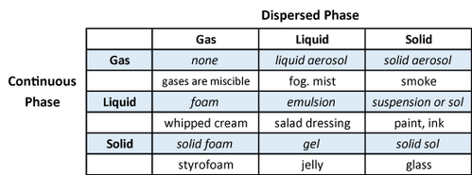
Surface of Colloids:
As particle size decreases, surface area increases as a function of total volume. In the colloidal size range there is much interest in particle-particle interactions. Most colloidal commercial products are designed to remain in a stable condition for a defined shelf life. Milk is an example where homogenization is used to reduce droplet size to delay the onset of phase separation (i.e., creaming with the fat rising to the surface). Commercial suspensions may be formulated to keep particles in suspension without sedimenting to the bottom.
Stability of Colloids:
Stabilization serves to protect colloids from aggregation and/or phase separation. The two main mechanisms for colloid stabilization involve steric and electrostatic modifications. Electrostatic stabilization is based on the mutual repulsion of like electrical charges. By altering the surface chemistry to induce a charge on the surface of particles it is possible to enhance the stability of the colloidal dispersion.
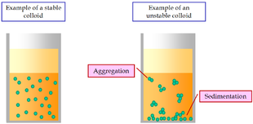

Zeta Potential:

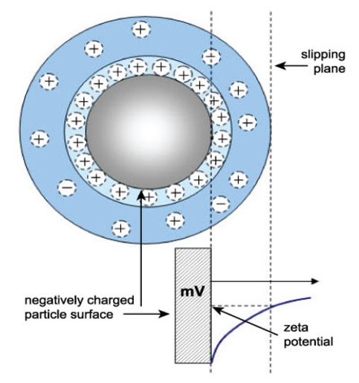

Zeta potential refers to the potential in the interfacial double layer at the location of the slipping plane versus a point in the bulk fluid away from the interface. In other words, zeta potential is the potential difference between the dispersion medium and the stationary layer of fluid attached to the dispersed particle. A classic example of colloid chemistry is to measure zeta potential vs. pH to determine the conditions where the zeta potential reaches zero, known as the isoelectric point.
*****

