Unit: 6.1

Introduction to Spectroscopy

Dr. D. Chakravarty.

1.9. The Beer – Lambert law: Molar Absorption Coefficient & Absorbance-

The Beer–Lambert law, relates the attenuation of light to the properties of the material through which the light is travelling. The law is commonly applied to chemical analysis measurements and used in understanding attenuation in physical optics, for photons, neutrons, or rarefied gases.
A demonstration of the Beer–Lambert law is given under green laser light in a solution of Rhodamine 6B. The beam radiant power becomes weaker as it passes through solution as shown in the Figure 01.
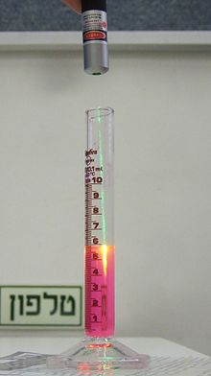
Figure 01.
Lambert's law (1728–1777) stated that the loss of light intensity when it propagates in a medium is directly proportional to intensity and path length. Much later, August Beer discovered another attenuation relation in 1852. Beer's law stated that the transmittance of a solution remains constant if the product of concentration and path length stays constant.
The modern derivation of the Beer–Lambert law combines the two laws and correlates the absorbance, which is the negative common logarithm of the transmittance, to both the concentrations of the attenuating species and the thickness of the material sample.
Definition & Equation:

The Beer-Lambert law states that the quantity of light absorbed by a substance dissolved in a fully transmitting solvent is directly proportional to the concentration of the substance and the path length of the light through the solution
The law was first developed by Pierre Bouguer before 1729. It was later attributed to Johann Heinrich Lambert who cited Bouguer’s findings. The law included path length as a variable that affected absorbance. Later, Beer extended in 1852 the law to include the concentration of solutions, thus giving the law its name Beer-Lambert Law.
Because Beer's law states this, it means we can both calculate the concentration of a solution by using the absorbancies, or plot a graph of various concentrations, align them to their correct absorbencies, and use a colorimeter to find the concentration of an unknown solution
The law states that:
A(λ) = e(λ) l c.
The proportionality constant e (λ) is called the absorptivity of the substance at the wavelength λ. e (λ) is called the molar absorptivity if the concentration is measured in moles/liter.
The absorbance is inversely proportional to the transmittence of the solution.
Derivation of the Law:
A spectrophotometer is an apparatus that measures the intensity, energy carried by the radiation per unit area per unit time, of the light entering a sample solution and the light going out of a sample solution. The two intensities can be expressed as transmittance: the ratio of the intensity of the exiting light to the entering light or percent transmittance (%T). Different substances absorb different wavelengths of light. Therefore, the wavelength of maximum absorption by a substance is one of the characteristic properties of that material. A completely transparent substance will have I_{t} = I₀ and its percent transmittance will be 100. Similarly, a substance which allows no radiation of a particular wavelength to pass through it will have I_{t} =0, and a corresponding percent transmittance of 0.
Transmittance
T = I_{t} / I₀
% Transmittance: %T = 100 T
Absorbance
A = log10 (I₀/I_{t})
A = log10 (1/T) = -log10 (T)
A = log10 (100/%T)
A = 2 - log10 (%T)
Transmittance for liquids is usually written as: T = I/I₀=10^{-αl} =10^{Σlc'}'
Transmittance for gases is written as T = I/I₀ = 10^{-α}l = e^{-σlN}
I₀ and I are the intensity (or power) of the incident light and the transmitted light, respectively.
Absorbance for liquids is written as A = -log10 = (I/I₀)
Absorbance for gases it is written as A´ = -ln(I/I₀)
Deviations of the Law:
The Beer-Lambert law maintains linearity under specific conditions only. The law will make inaccurate measurements at high concentrations because the molecules of the analyte exhibit stronger intermolecular and electrostatics interactions which is due to the lesser amount of space between molecules. This can change the molar absorptivity of the analyte. Not only does high concentrations change molar absorptivity, but it also changes the refractive index of the solution causing departures from the Beer-Lambert law.
Applications of the Law:
Beer-Lamberts law is applied to the analysis of a mixture by spectrophotometry, without the need for extensive pre-processing of the sample. Examples include the determination of bilirubin in blood plasma samples. The spectrum of pure bilirubin is known thus the molar absorbance is known. Measurements are made at one specific wavelength almost unique for bilirubin and another measurement at a second wavelength so interferences or deviations can be eliminated or corrected. Generally, it can be used to determine concentrations of a particular substance, or determine the molar absorptivity of a substance.

What is Absorbance ?
Absorbance (A), also known as optical density, is the quantity of light absorbed by a solution. Transmittance is the quantity of light that passes through a solution. Absorbance and % transmittance are often used in spectrophotometry and can be expressed by the following:

Absorbance equation:
A = Log₁₀ (I₀/I)
where I₀ is the intensity of the incident light, and I is intensity of that light after it passed through the sample
T = I/I₀ and %T = 100 (T)
The equation that allows one to calculate absorbance from % transmittance is
A = 2 - log₁₀ (%T)

Determine Concentration using the Beer-Lambert Law:
The concentration of a sample can be calculated from its absorbance using the Beer–Lambert law, which is expressed as follows:
A = ε * c * p
Where ε is the molar absorptivity, or molar extinction coefficient, in L mol⁻¹ cm⁻¹
c is the concentration of the solute in solution, in mol/L
p is the path length of the sample, in cm, for example 1 cm for a cuvette

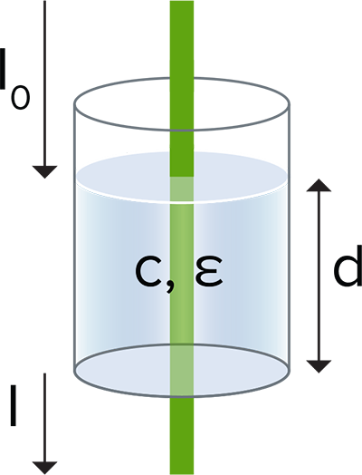
Ultraviolet (UV) measurements in microplates became possible when Molecular Devices introduced the first UV-capable microplate reader. Since then, the microplate measurements of DNA, RNA, and proteins that this enabled have become very popular. Learn more about how absorbance is measured, and some key applications that utilize absorbance.
*********

